**APPENDIX F: LOCKSETS AND ACCESS CONTROL**

**F.1 LOCKSETS**

The University (except for Housing Facilities which uses a Best 7-pin SFIC system) utilizes a Corbin Russwin 7-pin LFIC Core key system. Locksets shall accommodate University purchased and installed cores. Corbin Russwin 7-pin LFIC Core compatible cylinders and handles are to be provided by the vendor.

Facilities Management Lock Shop personnel shall accommodate the procurement, keying, and installation of the final cores. Construction or disposable cores shall be installed by the contractor during construction but will be removed prior to beneficial occupancy. Construction cores will become the property of the University unless stated otherwise and agreed upon with the Lock Shop.

Cylindrical Locksets shall be extra heavy-duty Grade 1 by Corbin/Russwin, Best or Schlage. All locksets shall have lever handles Corbin Russwin (NZD), Best (15D), Schlage (RHO) or match existing specs for the facility. Locksets must be compatible with Corbin 7-pin LFIC removable IC core supplied with red construction core (CT7R) or LFIC Disposable (CT7D).

Mortise Locksets shall be extra heavy-duty Grade 1 by Corbin/Russwin, Best or Schlage. All locksets shall utilize lever handles Corbin Russwin (LWA), Best (3R), Schlage (03), or match existing specs for the facility. Locksets must be compatible with Corbin 7-pin LFIC removable IC core cylinder housing supplied with red construction core (CT7R) or LFIC Disposable (CT7D) and allow one handed egress from inside grip. Schlage mortise locks must be provided with a Corbin 7-pin IC core compatible cylinder housing and have a A06 cam for Academic/Medical Center facilities.

Classroom, lecture hall, teaching laboratory and laboratory corridor access doors shall be equipped with locksets enabling occupants to readily secure door(s) from within the room. The basis of design for these locksets is Corbin/Russwin model ML2067, apartment function (deadbolt by key outside or by thumb turn inside, inside grip simultaneously retracts latch bolt and deadbolt permitting egress without unlocking door).

For classrooms, lecture halls and assembly rooms requiring more than one exit, electronic locking shall be provided from (a) University-agreed switch location(s) within these spaces, including where occupancy loads or agreed design parameters require panic hardware.

All panic hardware devices shall be heavy-duty, grade 1 push bar type supplied with a Corbin 7-pin IC core cylinder with red construction core (CT7R) (Best 7-pin SFIC core cylinders in housing projects), through bolted with sex bolts where possible, manufactured by Von Duprin, Corbin/Russwin or Sargent. The basis of design for panic hardware is Von Duprin model 9900 (and 9900E where electronic locking is applicable). Where electric latch retraction is required, exit device shall be Von Duprin QEL98/99 or QEL 33/35 series, no substitution.

See 1.4.3.5 Electronic Access Controls in University of Virginia’s 2018 Facility Design Guidelines for major entrances.

Unless exempted by an approved Determinations and Findings Report, exterior doors serving students, faculty, staff, and general public are to be card reader controlled. University student, faculty and staff identification systems are 24 VDC.

Hardware finish shall be Builder’s Hardware Manufacturing Association (BHMA) 630.

Use of combination locks is prohibited (as of January 2017). Upon failure of existing locks, the decision to replace existing locks or recommend access-controlled locks will be at the FM locksmith’s discretion.

**F.2 HEALTH SYSTEM DOOR LOCKING HARDWARE WITH ELECTRONIC ACCESS CONTROL**

When utilizing the following types of electronic access controls, use of the specified manufacturer and model is required to coordinate with existing electronic access control systems.

1. Single Door without Power Assist Device

a. Electric Strike (Modified Frame)

i. Full mortise lock and lever (Corbin-Russwin ML 2000 Series) ii. Electric strike (HES 1006, 1500’s, 1600’s Electric Strike)

* + 1. Electric Lock: Full mortise with request to exit function (Corbin Russwin ML 200901

ECL)

* + 1. Exit Door: Request to exit and panic bar with electric latch retraction (Von Duprin QEL)

1. Double Door without Power Assist Device
   * 1. Electric Mortise Lock: Full mortise and vertical rod device combination (Von Duprin

QEL Concealed Vertical Rod)

* + 1. Exit Device with Electric Latch Retraction: Two vertical rod devices, same direction with no overlapping astragal (Von Duprin EL99 Concealed Vertical Rod)

1. Double Door with Power Assist Devices

a. Door operator action initiated by card reader and wall plate

* + - 1. Auto opener, sensor, and touchless wall plate (Horton)
      2. Two vertical rod devices, same direction with no overlapping astragal (Von Duprin

QEL Concealed Vertical Rod)

b. Door operator action initiated by card reader action only

* + - 1. Auto opener, sensor, and relay for instant and delayed action (Horton)
      2. Two vertical rod devices, same direction with no overlapping astragal (Von Duprin QEL Concealed Vertical Rod)

1. Dual Door (egress both directions) without Power Assist Device

a. Card Reader Unlock

i. Concealed vertical rod device on secure side with no overlapping astragal (Von

Duprin QEL Concealed Vertical Rod) ii. Concealed vertical rod device to meet requirement for special locking arrangement of non-secure side with no overlapping astragal (Von Duprin CHEXIT Controlled Exit

Device, Board Contains Infinite Delay)

b. Door Operator action initiated by card reader action only

* + - 1. Auto opener, sensor, and relay for instant and delayed action (Horton)
      2. Two Vertical Rod Deices, same direction with no overlapping astragal (Von Duprin QEL Concealed Vertical Rod)

1. Access Control
   * 1. Readers are to be HID Signo 40 for wall mount; HID Signo series I-class reader for mullion mounted
     2. All reader requests should be directed to the “UVA Health” Manager for Electronic Security

**F.3 ACADEMIC DIVISION DOOR LOCKING HARDWARE WITH ELECTRONIC ACCESS CONTROL**

When utilizing the following types of electronic access controls, use of the specified manufacturer and model is required to coordinate with existing electronic access control systems.

1. Electric strike for mortise & cylindrical locks: Von Duprin 6000 series
2. Electric strike, surface mount for rim exit device: HES Genesis series 9600, 9500, or 9400 (surface mounted for use with rim exit device)
3. Electric mortise lock:
   1. Academic buildings: Corbin Russwin ML20900 ECL series with M92 option (request to exit)
   2. Residence Halls: Schlage L9000 series with EU and RX options
4. Electric cylindrical lock
   1. Academic buildings: Corbin Russwin CL33900 series with M92 option (request to exit)
   2. Residence Halls: Schlage L9000 series with EU and RX options
5. Electric latch retraction exit device:
   1. Von Duprin 98/99 series with QEL and RX options
   2. Von Duprin 33A/35A series with QEL and RX options (for narrow stile doors)
   3. Trim shall be night latch operation with lever handle
6. Electric trim (for use with Von Duprin exit device)
   1. 98/99 series: E996L, night latch operation with lever handle
   2. 33A/35A series: E360L, lever handle (cylinder unavailable)

7. Wireless Locks:

* 1. Schlage AD series locks and controls provided by the University for installation by contractor
  2. Schlage AD series locks (mortise, mortise-deadbolt, or cylindrical)
     1. Classrooms, labs, and offices: Function 70
     2. Classrooms requiring deadbolt for shelter-in-place: Function 40
     3. Residence rooms: Function 50
  3. Schlage AD400-993 exit trim for Von Duprin 98/99 series
  4. Credential Reader:
     1. MSK (Residence Halls)
     2. MS (Academic)
  5. Schlage wireless system accessories:
     1. PIM400-485 Panel Interface Module
     2. GCK400/ECK400 Wireless Gate & Elevator Kit iii. ANT400-REM Remote Antenna Module

8. Electric power transfer: Von Duprin EPT-10

9. Electrified hinge:

1. Butt hinge: Minimum of six conductors, two must be 18 ga
2. Continuous hinge: Section containing wires must be separate from main hinge, removable, and field replaceable
3. DC power supplies:
   * 1. Altronix ALX1012ULXPD16 (12 Vdc)
     2. Altronix ALX1024ULXPD16 (24 Vdc)
     3. Altronix Maximal Series
4. Card Readers
   * 1. Standard reader: Schlage MT 11 or MT 15
     2. Where keypad is required: Schlage aptiQ MTK15
5. Custom modular access control cable, provided by the University for installation by contractor:
   * 1. Standard cable:
        1. Outer Jacket PURPLE color in LOW SMOKE/PLENUM with text "UVA Access Control: Call 434-982-5735”
        2. Element #1: 22-08 Shielded PLNM, Yellow Stripe – text “Card Reader”
        3. Element #2: 22-06 Non-shielded PLNM, Orange Stripe – text “Motion/REX”
        4. Element #3: 22-04 Non-shielded PLNM, Green Stripe – text “Door Contact/Spare”
        5. Element #4: 18-04 Non-shielded PLNM, Purple Stripe – text “Lock Power”
     2. Cable for openings with power operator:
        1. Outer Jacket PURPLE color in LOW SMOKE/PLENUM with text "UVA Access Control: Call 434-982-5735”
        2. Element #1: 22-08 Shielded PLNM, Yellow Stripe – text “Card Reader”
        3. Element #2: 22-06 Non-shielded PLNM, Orange Stripe – text “Motion/REX”
        4. Element #3: 22-06 Non-shielded PLNM, Green Stripe – text “Door Contact/Spare”
        5. Element #4: 18-04 Non-shielded PLNM, Purple Stripe – text “Lock Power”
6. Access control system: CBORD CS Access®
   * 1. EAC installer must provide evidence of CBORD training/certification in installation and wiring of HID® Mercury™ LP Series intelligent controllers
     2. System configuration and architecture must be reviewed and approved by the

University prior to installation

* + 1. Mercury™ controls are provided by the University for installation by contractor

1. Electric surge suppression: AC circuits supplying electronic access controls must be protected with inline surge suppression. Ditek Corporation DTK-120HW
2. Relays
   * 1. BEA BR3 programmable relay: Used with ADA operator to provide request-to-exit, door unlatch, and door open sequence from interior actuator.
     2. Altronix RB1224 double-pole double-throw relay: Used with ADA operator to disable exterior actuator when door is locked.

**F.4 CPTED RELATED FIXTURES**

**Figure F1: Squadron Controls Dedicated Closet** 5

**Figure F2: Squadron Controls in Enclosure** 6

**Figure F3: Single Door with Electric Strike** 7

**Figure F4: Single Door with Electric Lock** 8

**Figure F5: Single Door with Electric Trim** 9

**Figure F6: Single Door with Latch Retraction** 10

**Figure F7: Single Door with ADA & Electric Strike** 11

**Figure F8: Single Door with ADA & Latch Retraction** 12

**Figure F9: Double Door with Electric Strike** 13

**Figure F10: Double Door with Electric Lock** 14

**Figure F11: Double Door with Electric Trim** 15

**Figure F12: Double Door with Latch Retraction** 16

**Figure F13: Double Door with Latch Retraction Holder** 17

**Figure F14: Double Door with ADA Latch Retraction Storefront** 18

**Figure F15: Double Door with Ada Latch Retraction Raceway via Operator** 19

**Figure F16: Residence Room AD400 Lock** 20

**Figure F17: Wireless Lock with Local Alarm** 21

**Figure F18: Wireless Lock with Horn, Holder, and Closer** 22

**Figure F19: Overhead Door with Alarm** 23

**Figure F20: Double Door with ADA, Strike, Reader, Rex, and Horn** 24

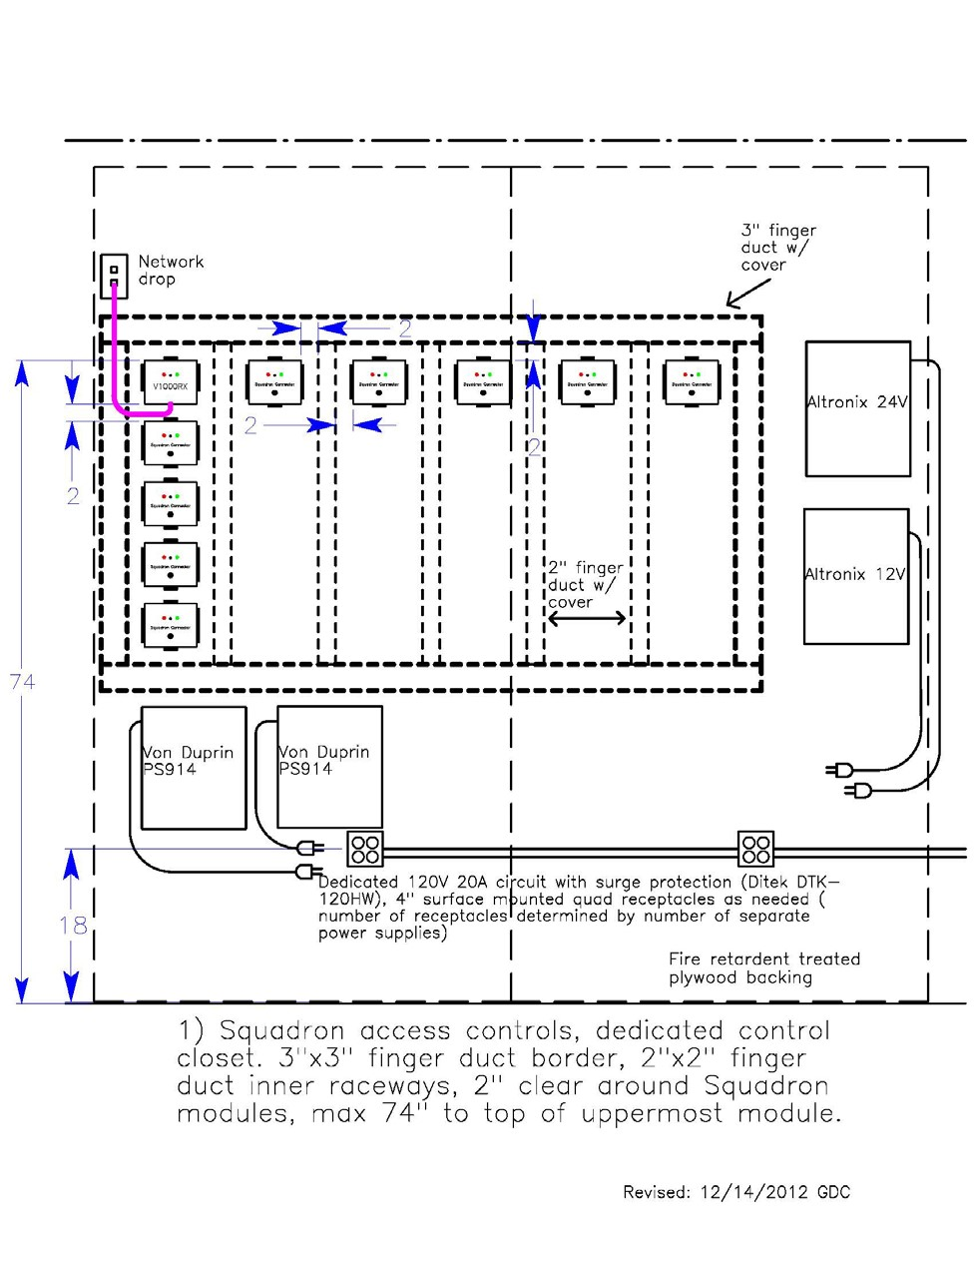

# Figure F1: Squadron Controls Dedicated Closet

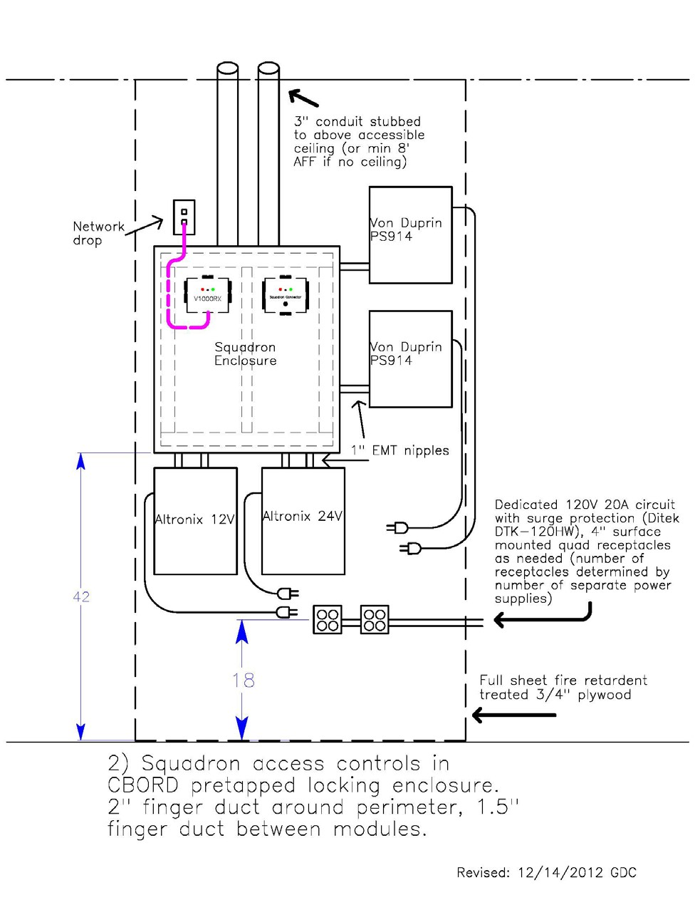

# Figure F2: Squadron Controls in Enclosure

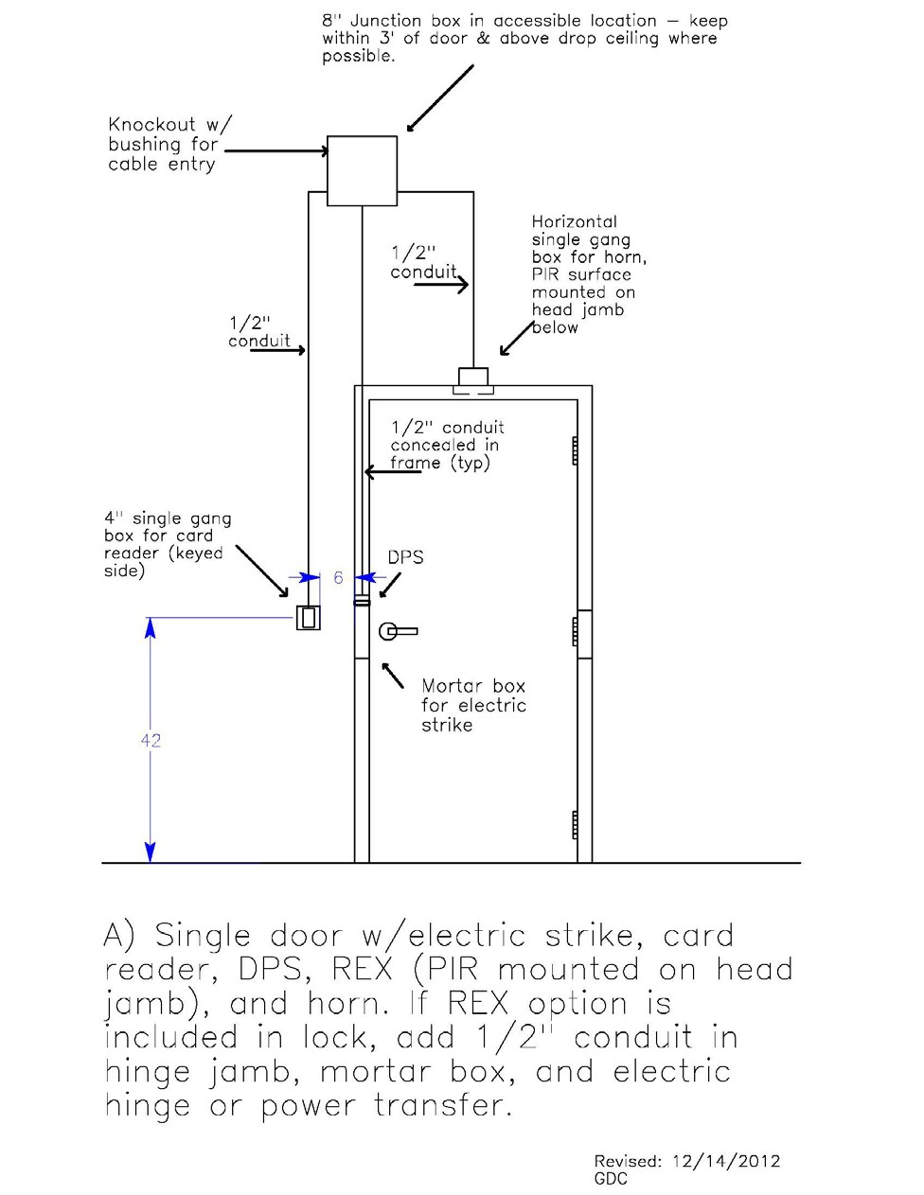

# Figure F3: Single Door with Electric Strike

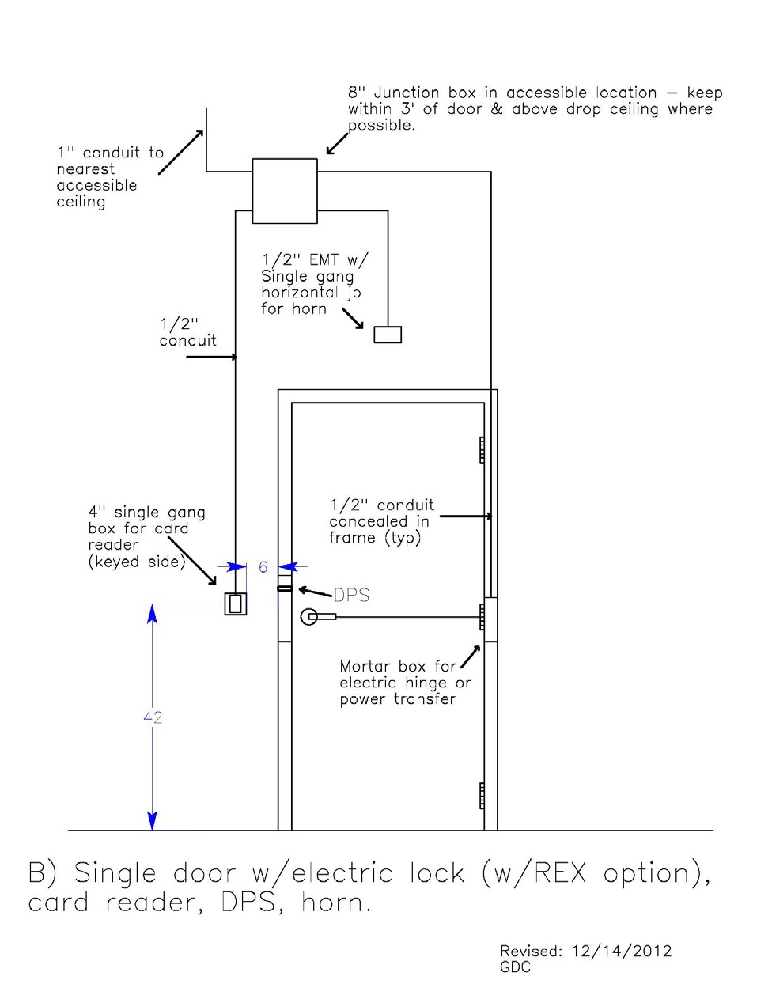

# Figure F4: Single Door with Electric Lock

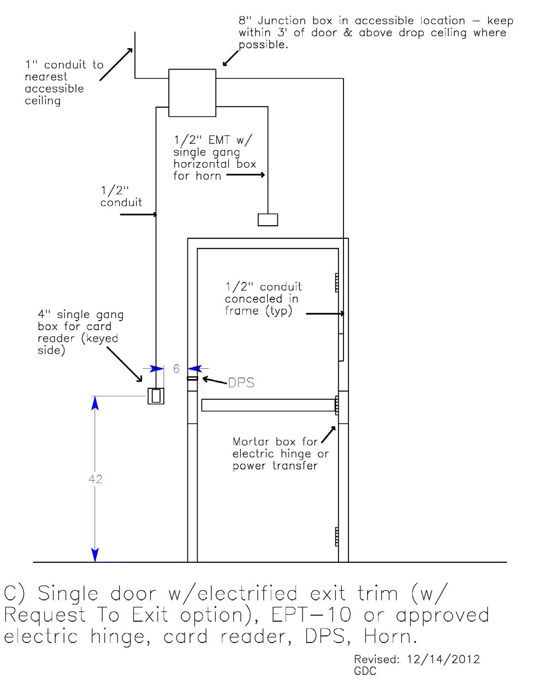

# Figure F5: Single Door with Electric Trim

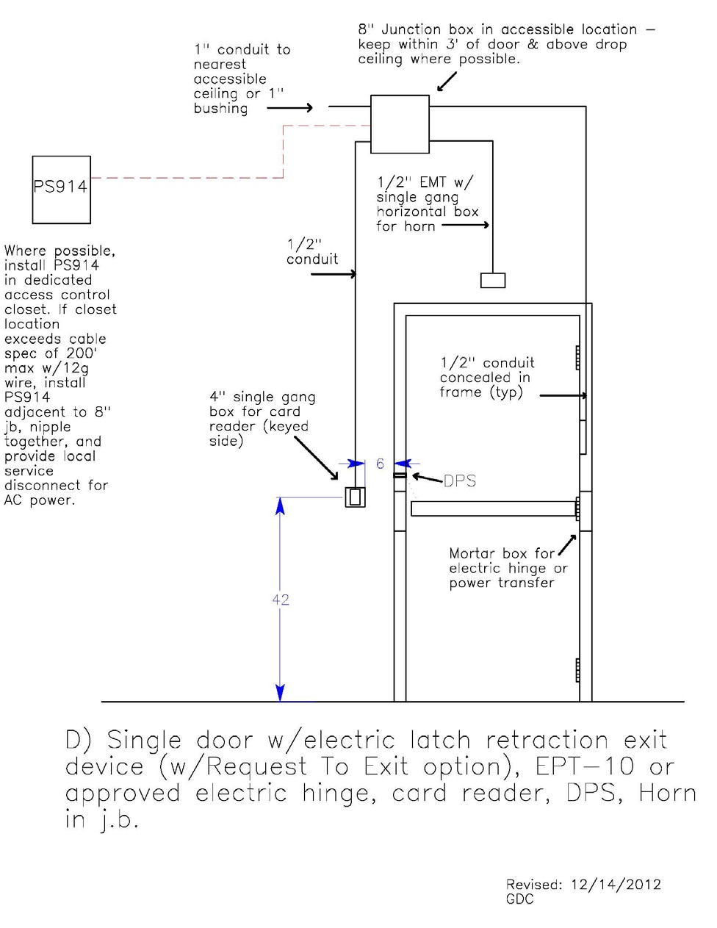

# Figure F6: Single Door with Latch Retraction

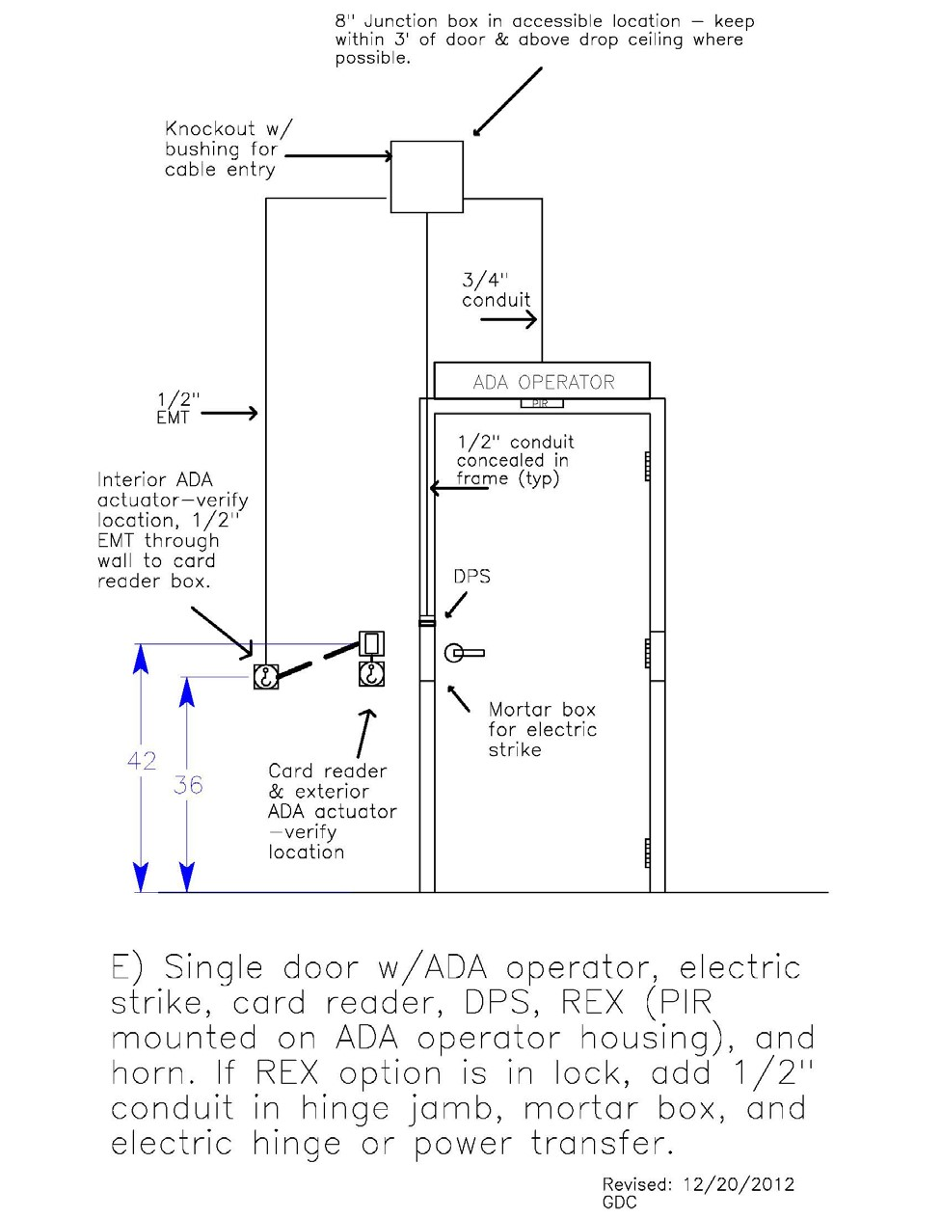

# Figure F7: Single Door with ADA & Electric Strike

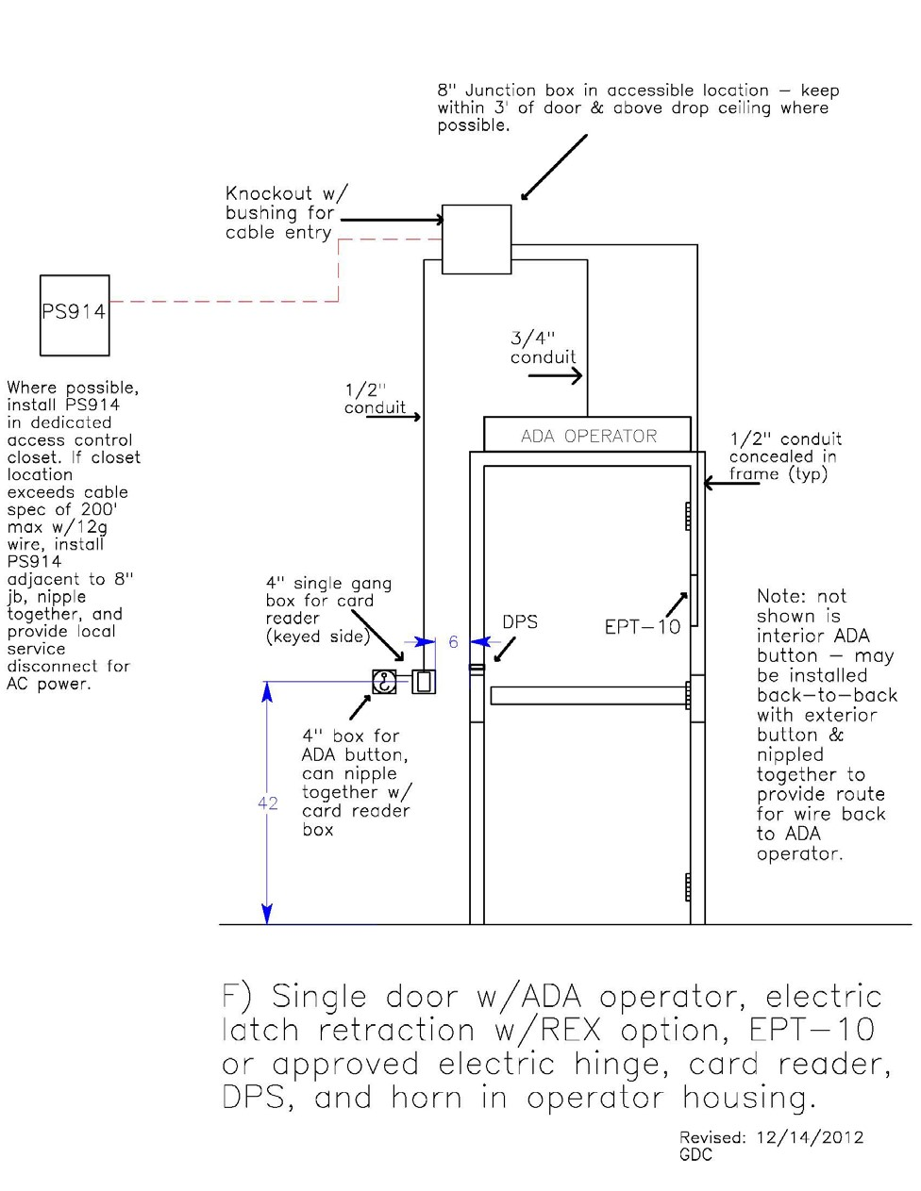

# Figure F8: Single Door with ADA & Latch Retraction

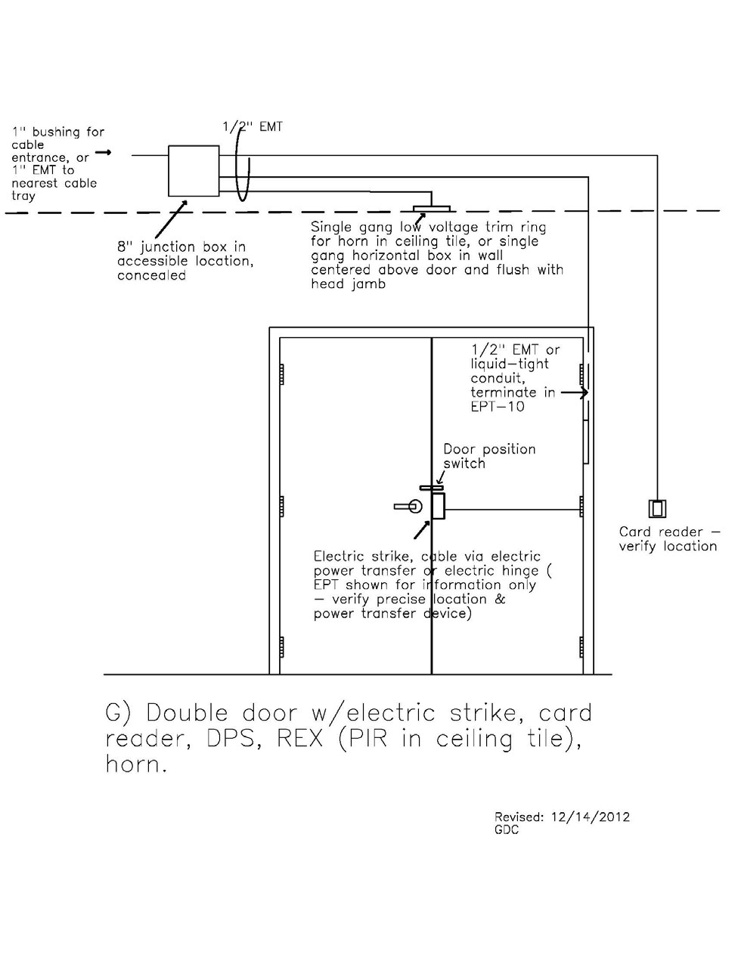

# Figure F9: Double Door with Electric Strike

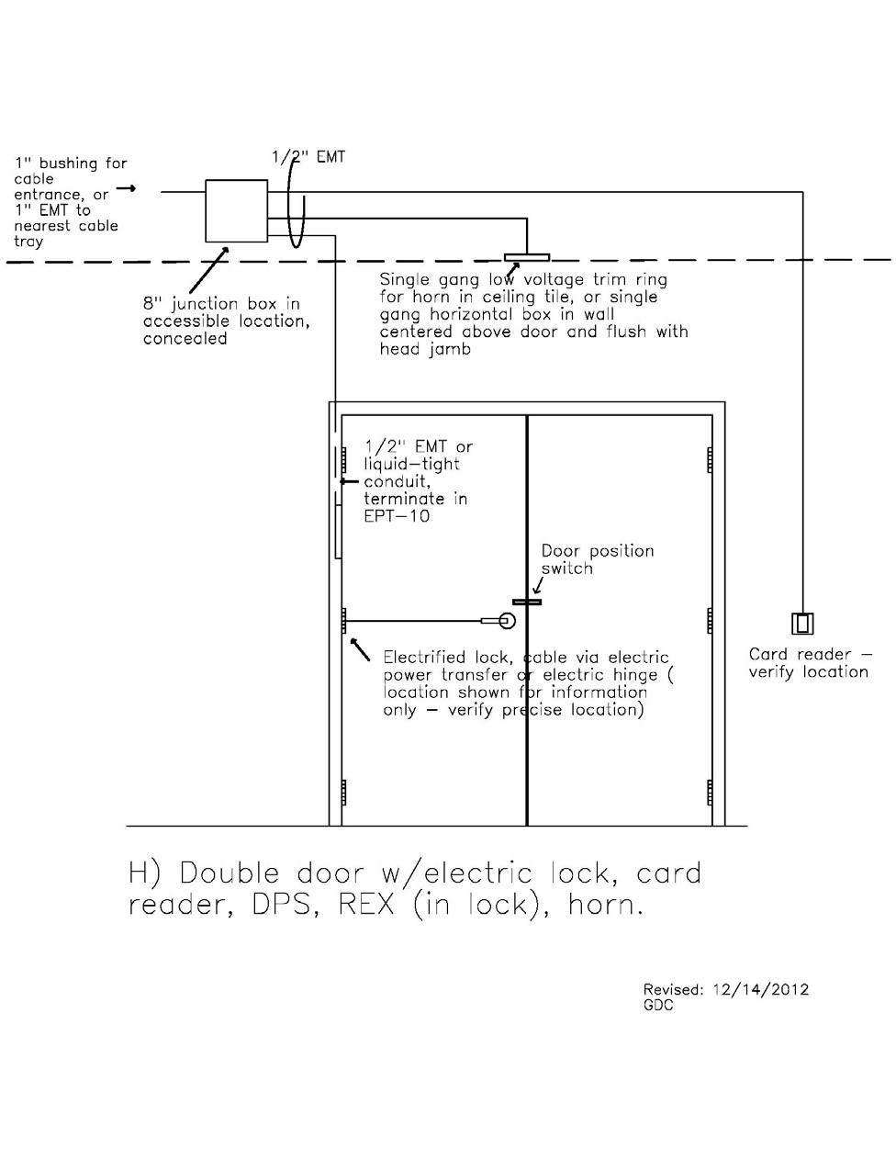

# Figure F10: Double Door with Electric Lock

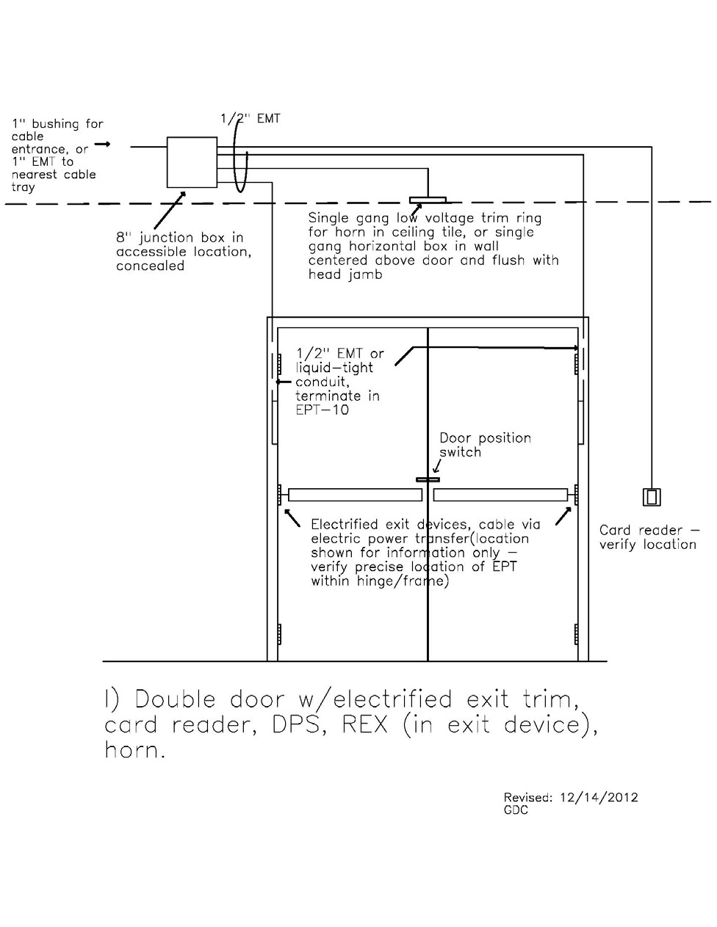

# Figure F11: Double Door with Electric Trim

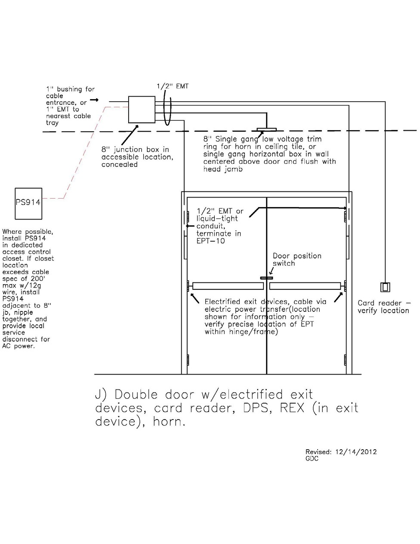

# Figure F12: Double Door with Latch Retraction

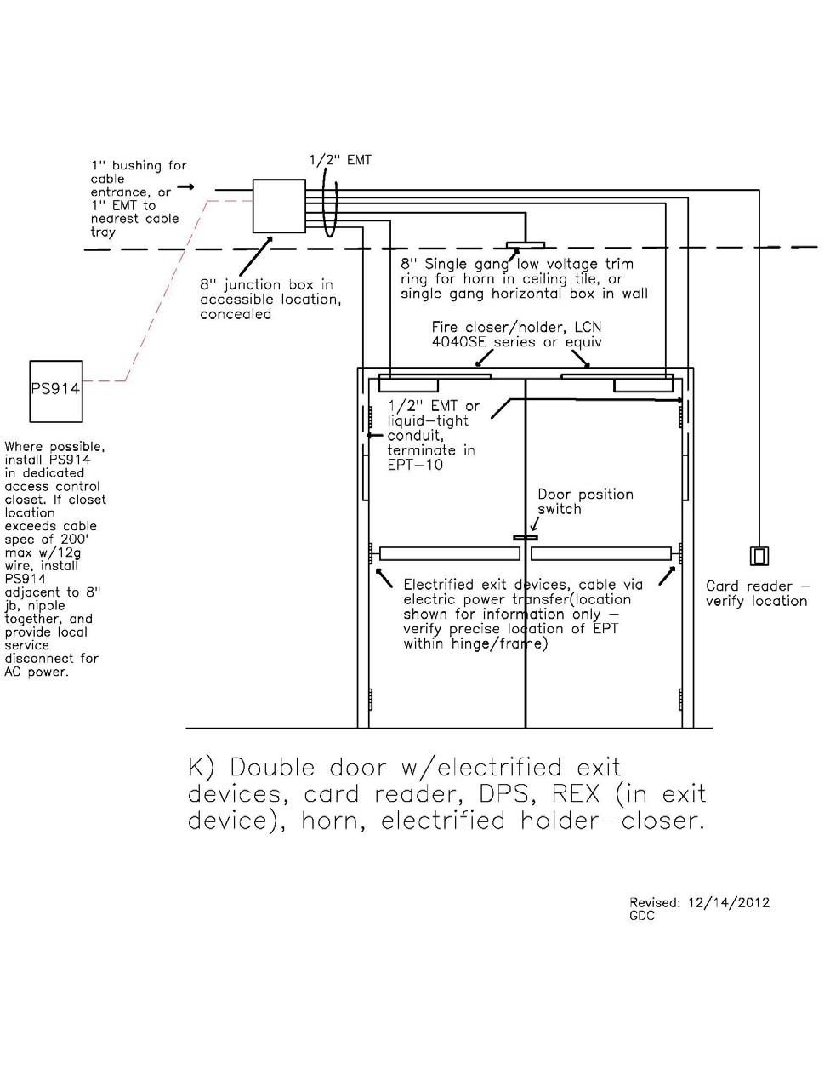

# Figure F13: Double Door with Latch Retraction Holder

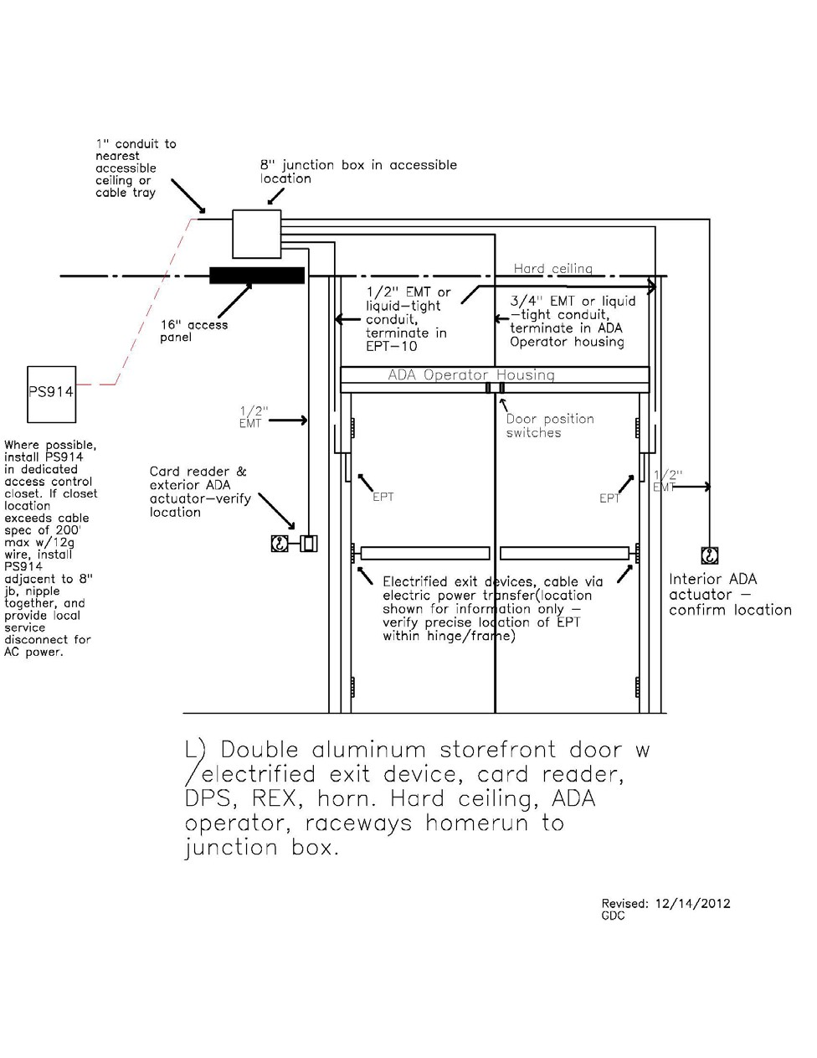

# Figure F14: Double Door with ADA Latch Retraction Storefront

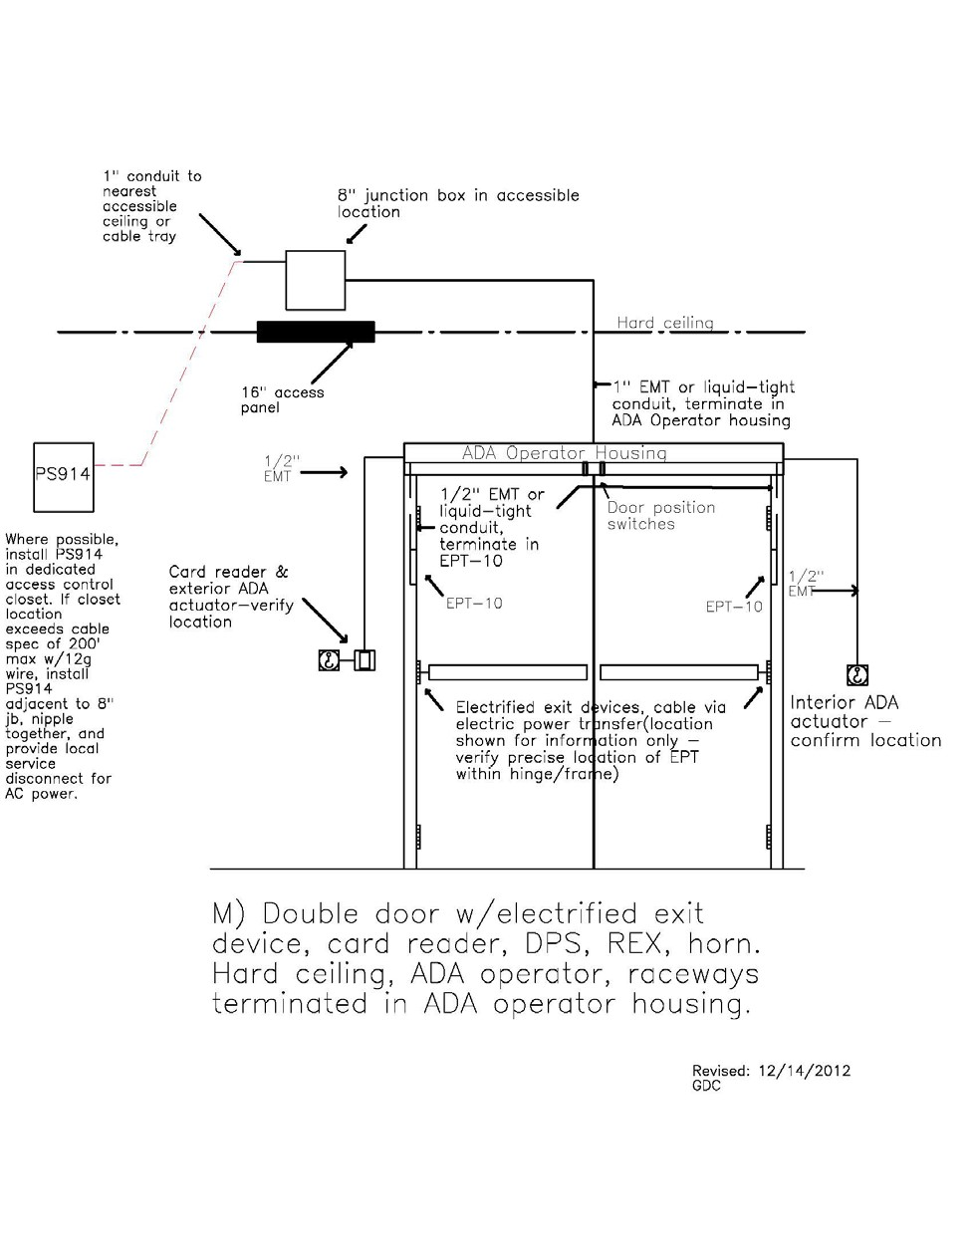

# Figure F15: Double Door with Ada Latch Retraction Raceway via Operator

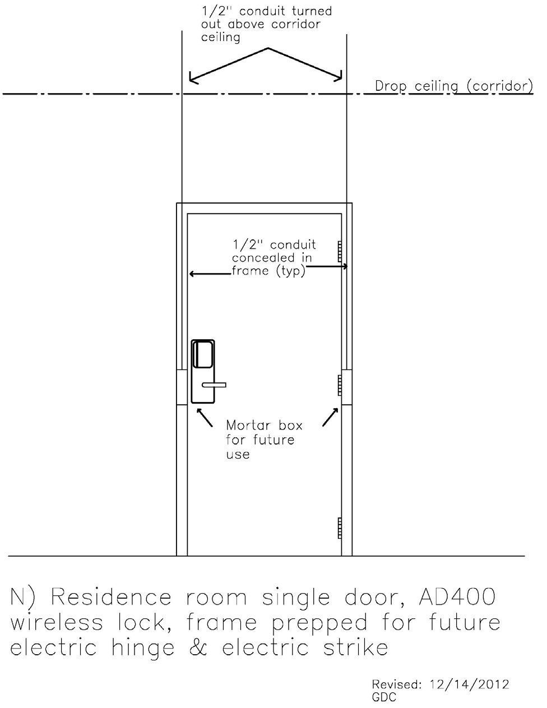

# Figure F16: Residence Room AD400 Lock

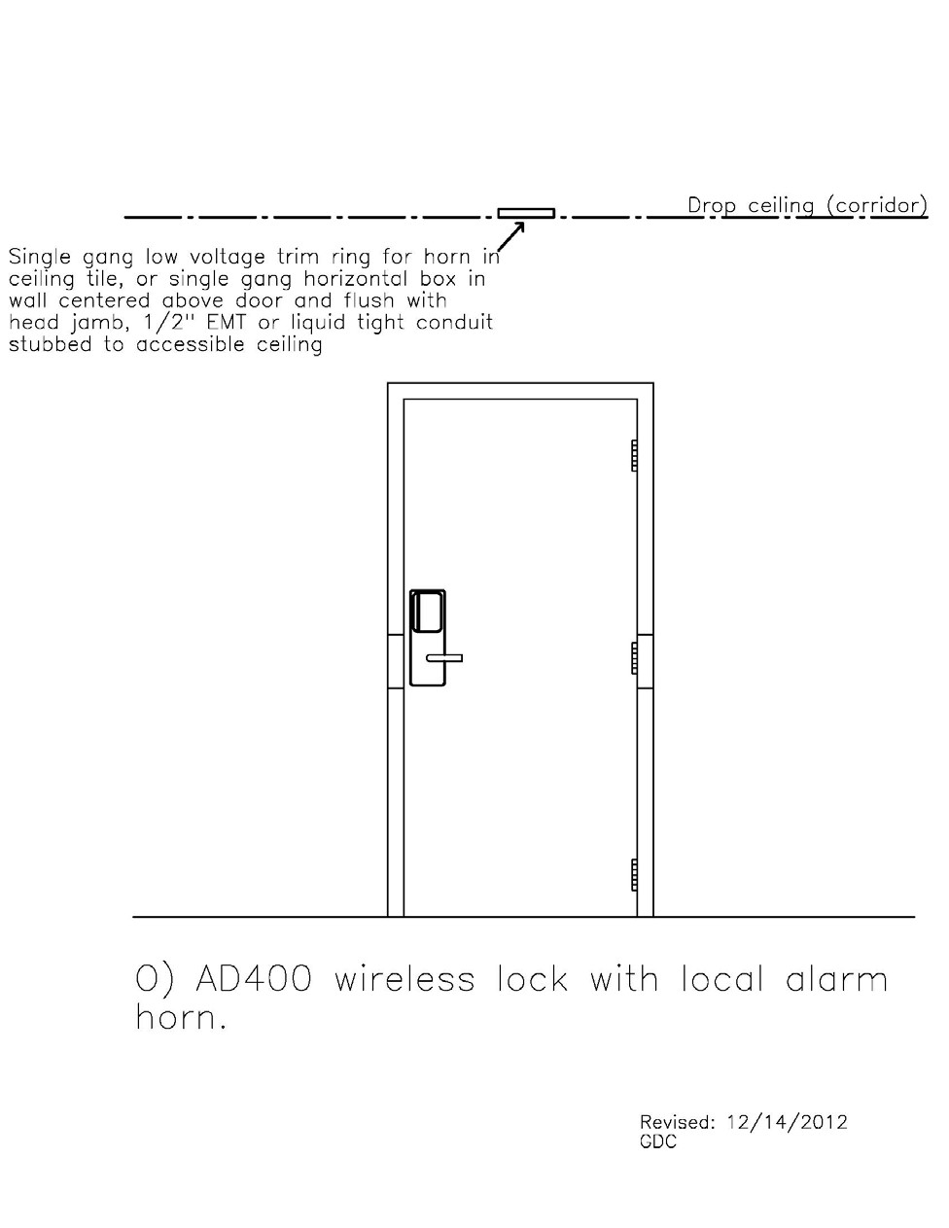

# Figure F17: Wireless Lock with Local Alarm

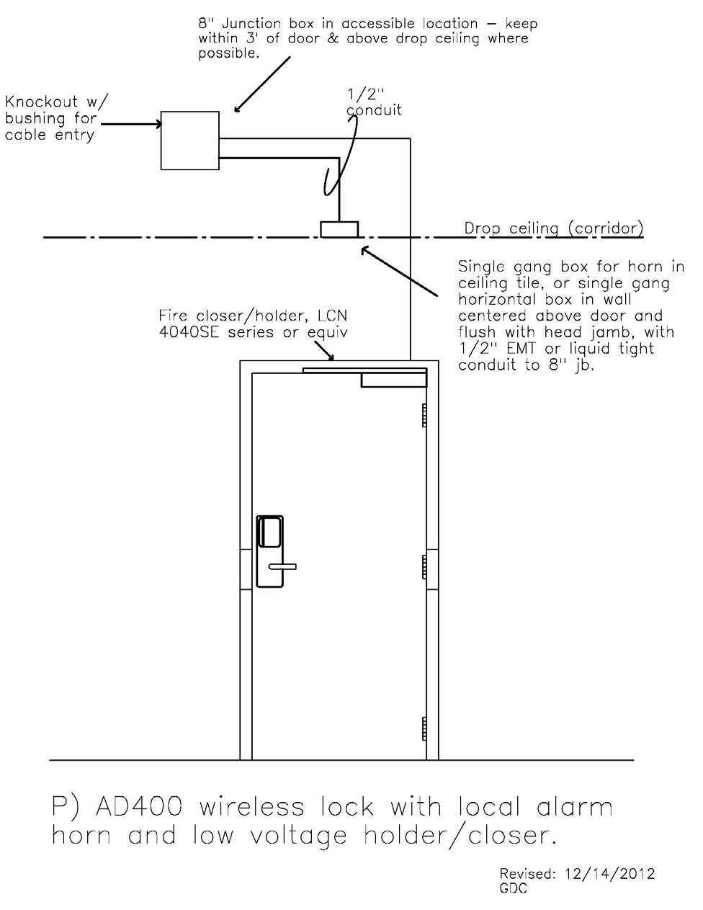

# Figure F18: Wireless Lock with Horn, Holder, and Closer

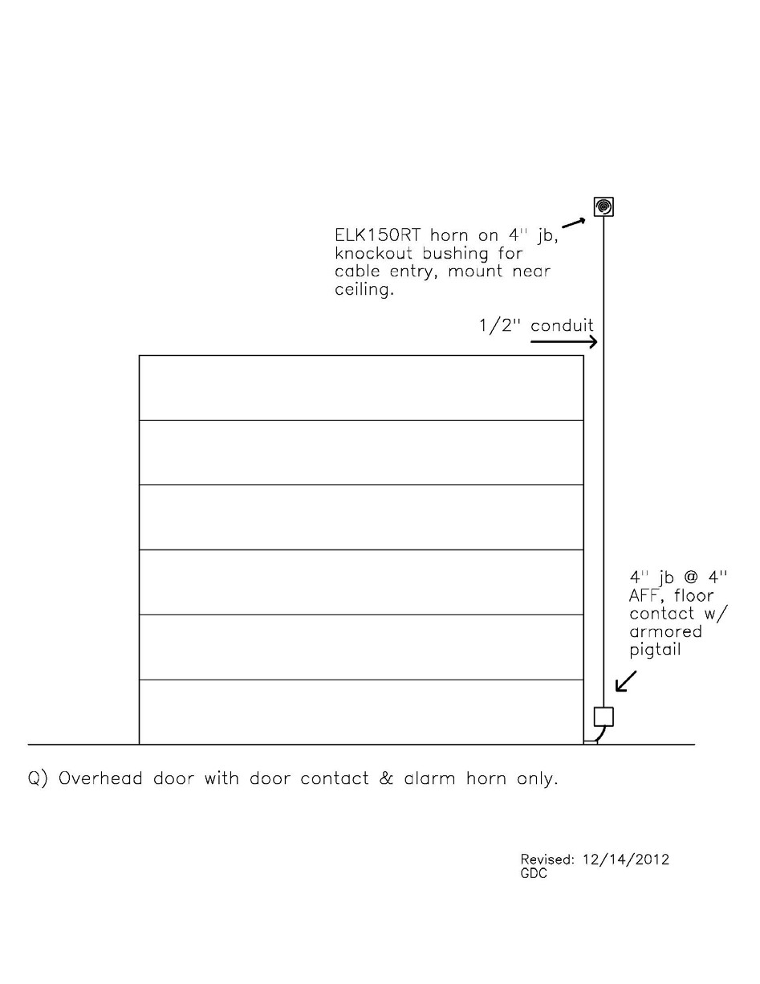

# Figure F19: Overhead Door with Alarm

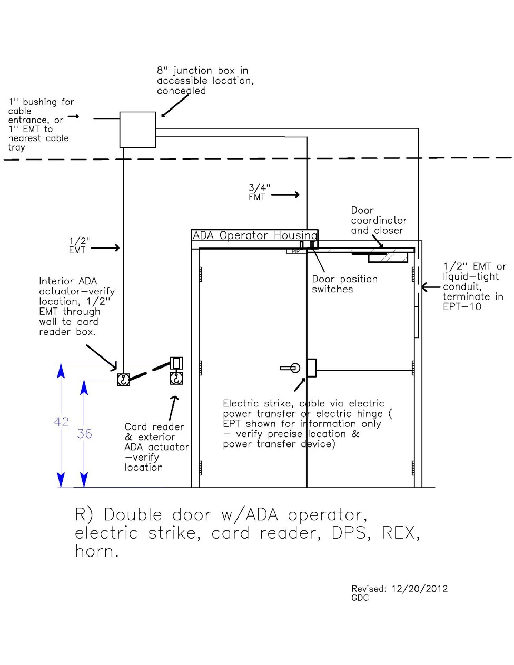

# Figure F20: Double Door with ADA, Strike, Reader, Rex, and Horn