APPENDIX F: LOCKSETS AND ACCESS CONTROL

F.1 LOCKSETS
The University (except for Housing Facilities which uses a Best 7-pin system) utilizes a Corbin Russwin 7-pin LFIC Core key system. Locksets shall accommodate University purchased and installed cores. Corbin Russwin 7-pin LFIC Core compatible cylinders and handles are to be provided by the vendor.
Facilities Management Lock Shop personnel shall accommodate the procurement, keying and installation of the final cores. Construction or disposable cores shall be installed by the contractor during construction but will be removed prior to beneficial occupancy. Construction cores will become the property of the University unless stated otherwise and agreed upon with the Lock Shop.
Cylindrical Locksets shall be extra heavy-duty Grade 1 by Corbin/Russwin, Best or Schlage. All locksets shall have lever handles Corbin Russwin (NZD), Best (15D), Schlage (RHO) or match existing specs for the facility. Locksets (except for housing facilities) must be compatible with Corbin 7-pin LFIC removable IC core supplied with red construction core (CT7R) or LFIC Disposable (CT7D).
Mortise Locksets shall be extra heavy-duty Grade 1 by Corbin/Russwin, Best or Schlage. All locksets shall utilize lever handles Corbin Russwin (LWA), Best (3R), Schlage (03), or match existing specs for the facility. Locksets must be compatible with Corbin 7-pin LFIC removable IC core cylinder housing (except for housing facilities) supplied with red construction core (CT7R) or LFIC Disposable (CT7D) and allow one handed egress from inside grip. Schlage mortise locks must be provided with a Corbin 7-pin IC core compatible cylinder housing and have a A06 cam for Academic/Medical Center facilities.
Classroom, lecture hall, teaching laboratory and laboratory corridor access doors shall be equipped with locksets enabling occupants to readily secure door(s) from within the room. The basis of design for these locksets is Corbin/Russwin model ML2067, apartment function (deadbolt by key outside or by thumb turn inside, inside grip simultaneously retracts latch bolt and deadbolt permitting egress without unlocking door).
For classrooms, lecture halls and assembly rooms requiring more than one exit and greater than 60 occupants, electronic locking shall be provided from (a) University- agreed switch location(s) within these spaces, including where occupancy loads or agreed design parameters require panic hardware.
All panic hardware devices shall be heavy-duty, grade 1 push bar type supplied with a Corbin 7-pin IC core cylinder with red construction core (CT7R) (Best 7-pin IC core cylinder in housing projects), through bolted with sex bolts where possible, manufactured by Von Duprin or Corbin/Russwin. The basis of design for panic hardware is Von Duprin model 9900 (and 9900E where electronic locking is applicable). Where electric latch retraction is required, the exit device shall be Von Duprin QEL98/99 or QEL 33/35 series, no substitution.
See 1.4.3.5 Electronic Access Controls in University of Virginia’s 2024 University Design Guidelines for major entrances.

Unless exempted by an approved Determinations and Findings Report, exterior doors serving students, faculty, staff and general public are to be card reader controlled. University student, faculty and staff identification systems are 24 VDC.
Use of combination locks is prohibited (as of January 2017). Upon failure of existing locks, the decision to replace existing locks or recommend access controlled locks will be at the FM locksmith’s along with The Department of Safety Security’s discretion.

HEALTH SYSTEM DOOR LOCKING HARDWARE

- When utilizing the following types of electronic access controls, use of the specified manufacturer and model is required to coordinate with existing electronic access control systems.
- Single Door without Power Assist Device
  - Electric Strike (Modified Frame)
    - Full mortise lock and lever (Corbin-Russwin ML 2000 Series)
    - Electric strike (Folger Adams 712-75 Electric Strike)
  - Electric Lock: Full mortise with request to exit function (Corbin Russwin ML 200901 ECL)
  - Exit Door: Request to exit and panic bar with electric latch retraction (Von Duprin QEL- RX 99NL)
- Double Door without Power Assist Device
  - Electric Mortise Lock: Full mortise and vertical rod device combination (Von Duprin QEL- RX 99NL) Concealed Vertical Rod)
  - Exit Device with Electric Latch Retraction: Two vertical rod devices, same direction with no overlapping astragal (Von Duprin QEL-RX 99NL Concealed Vertical Rod)
- Double Door with Power Assist Devices
  - Door operator action initiated by card reader and wall plate
    - Auto opener, sensor and touchless wall plate (Horton)
    - Two vertical rod devices, same direction with no overlapping astragal (Von Duprin QEL-RX 99NL Concealed Vertical Rod)
  - Door operator action initiated by card reader action only
    - Auto opener, sensor and relay for instant and delayed action (Horton)
    - Two vertical rod devices, same direction with no overlapping astragal (Von Duprin QEL-RX 99NL Concealed Vertical Rod)
- Dual Door (egress both directions) without Power Assist Device
  - Card Reader Unlock
    - Concealed vertical rod device on secure side with no overlapping astragal (Von Duprin QEL-RX 99NL Concealed Vertical Rod)
    - Concealed vertical rod device to meet requirement for special locking arrangement of non-secure side with no overlapping astragal (Von Duprin Chexit Controlled Exit Device, Board Contains Infinite Delay)
  - Door Operator action initiated by card reader action only
- Access Control
  - Readers are to be HID R40 for wall mount; HID R10 for mullion mounted
  - All reader requests should be directed to the Manager Clinical Engineering Services

ACADEMIC DIVISION DOOR LOCKING HARDWARE WITH ELECTRONIC ACCESS CONTROL

- When utilizing the following types of electronic access controls, use of the specified manufacturer and model is required to coordinate with existing electronic access control systems.
- Electric strike for mortise & cylindrical locks: Von Duprin 6000 or HESS 1000 series.
- Electric strike, surface mount for rim exit device: HES Genesis series 9600, 9500, or 9400 (surface mounted for use with rim exit device)
- Mag Locks are not permitted unless the use of a Magnetic style lock is the only option that will allow for a door or set of doors to be lockable with access control systems. Additional devices may be required. The use of magnetic-style locks must be approved prior to installation by the Department of Safety and Security and the Facilities Management Lock Shop.
- Electric mortise lock:
  - Academic buildings: Corbin Russwin ML20900 ECL series with M92 option (request to exit)
  - Residence Halls: Schlage L9000 series with EU and RX (Electronically Unlocked, Request to Exit) options.
- Electric cylindrical lock
  - Academic buildings: Corbin Russwin CL33900 series with M92 option (request to exit)
  - Residence Halls: Schlage ND80BDEU
- Electric latch retraction exit device:
  - Von Duprin 98/99 series with QEL and RX options
  - Von Duprin 33A/35A series with QEL and RX options (for narrow stile doors)
  - Trim shall be night latch operation with lever handle.
- Electric trim (for use with Von Duprin exit device)
  - 98/99 series: E996L, night latch operation with lever handle.
  - 33A/35A series: E360L, lever handle (cylinder unavailable)
- Wireless Locks:
  - Schlage AD series locks, NDE, LE and controls provided by approved vendor.
  - Schlage AD series locks (mortise, mortise-deadbolt, or cylindrical)
    - Classrooms, labs and offices: Function 70
    - Classrooms requiring deadbolt for shelter-in- place: Function 40
    - Residence rooms: Function 50
  - Schlage AD400 or AD300-993 exit trim for Von Duprin 98/99 series
- Credential Reader
  - MTBK2 (Residence Halls)
  - MTB2 (Academic)
- Schlage wireless system accessories:
  - PIM400-485 Panel Interface Module
  - ANT400-REM Remote Antenna Module
- Power Transfer: Must be separate from main hinge, removable, and field replaceable.
  - Electric power transfer: Von Duprin EPT-10
  - Electrified hinge:
    - Butt hinge: Minimum of six conductors, two must be 18 ga
- Closers
  - LCN 4040SE Sentronic
- Hold Opens
  - Hold Opens-Closer (1) per leaf: 4040XP-RW/PA 689
  - Mag hold opens (1) per leaf: LCN SEM7850, 689 AL

- Flush Bolts- Required for double doors securing space
  - Rockwood Self Latching Automatic
- Power supplies (New Standard):
- Life Safety FP075-B100M8PNL4E4M-WT-UVA (RS2) (120 VAC, 75W, 4 Managed)
- Life Safety FP150-B100M8PNL4E6M-WP-UVA (RS2) (120 VAC, 150W, 8 Managed)
- Life Safety FP150\250-2D8P2M8PNL4E8M2-WP-UVA (RS2) (120 VAC, 400W, 16 Managed)
- Card Readers
  - Standard reader: Schlage MTB 11 or MTB 15
  - Where keypad is required: Schlage-MTKB15
- Custom modular access control cable, provided by university for installation by contractor:
  - Standard Composite cable:
    - Outer Jacket YELLOW color in LOW SMOKE/PLENUM
    - Element #1: 22/1P Shielded, Lo-Cap, Tinned Copper, RS-485, 120 Ohms; + 18-2 Conductor Non Shielded, Bare Copper White Jacket – text “OSDP”
    - Element #2: 18-04 Conductor Non-shielded, Bare Copper White Jacket W/ Orange Stripe – text “Lock Power”
    - Element #3: 22-04 Conductor Non-shielded, Bare Copper White Jacket W/ Red Stripe – text “REX/SPARE”
    - Element #4: 22-02 Conductor Non-shielded, bare Copper, White Jacket W/ Green Stripe – text “Door Contact”
  - Cable for openings with power operator:
    - Standard Composite Cable
    - 22-08 Conductor, Non-Shielded, Bare Copper, Plenum, White Jacket.
  - Cable for Schlage PIM modules and Gateways: 2 element plenum rated composite cable
    - Outer Jacket: Teal/Yellow stripe
    - Element #1: 18-02 conductor unshielded
    - Element #2: 22/1P Shielded
- Access control system: Access It
  - PACS installer must provide evidence of DCJS Certification and Access IT training/certification in installation, configuration and wiring of HID® Mercury™ LP Series intelligent controllers
  - System configuration and architecture must be submitted to the University for approval prior to installation.
- Mercury™ controls are provided and installed by university approved vendor
- Electric surge suppression: AC circuits supplying electronic access controls must be protected with inline surge suppression. Ditek Corporation DTK-120HW or incorporated within Life Safety power supplies
- Relays
  - BEA BR3 programmable relay: Used with ADA operator to provide request-to- exit, door unlatch, and door open sequence from interior actuator.
  - Altronix RB1224 double-pole double-throw relay: Used with ADA operator to disable exterior actuator when door is locked.
- ADA Operator
  - Horton 4000 Series
  - LCN 9500/2800 Senior Swing
- ADA Operator stand-alone kits: (Restrooms)
  - Touchless BEA-10MSRR-SGPS or BEAMSRR-DGPS (Single or Double Door)
  - BEA Restroom Kit

HOUSING DIVISION DOOR LOCKING HARDWARE WITH ELECTRONIC ACCESS CONTROL

- When utilizing the following types of electronic access controls, use of the specified manufacturer and model is required to coordinate with existing electronic access control systems.
- Electric strike for mortise & cylindrical locks: Von Duprin 6000 or HESS 1000 series.
- Electric strike, surface mount for rim exit device: HES Genesis series 9600, 9500, or 9400 (surface mounted for use with rim exit device)
- Mag Locks are not permitted.
- Electric mortise lock:
  - Residence Halls: Schlage L9000 series with EU and RX (Electronically Unlocked, Request to Exit) options.
- Electric cylindrical lock
  - Residence Halls: Schlage ND80BDEU
- Electric latch retraction exit device:
  - Von Duprin 98/99 series with QEL and RX options
  - Von Duprin 33A/35A series with QEL and RX options (for narrow stile doors)
  - Trim shall be night latch operation with lever handle.
- Electric trim (for use with Von Duprin exit device)
  - 98/99 series: E996L, night latch operation with lever handle.
  - 33A/35A series: E360L, lever handle (cylinder unavailable)
- Wireless Locks:
  - Schlage AD series locks, NDE, LE and controls provided by approved vendor.
  - Schlage AD series locks (mortise, mortise-deadbolt, or cylindrical)
    - Residence rooms: Function 50
  - Schlage AD400 or AD300-993 exit trim for Von Duprin 98/99 series
  - Credential Reader
    - MTBK2
    - MTB2
- Schlage wireless system accessories:
  - PIM400-485 Panel Interface Module
  - ANT400-REM Remote Antenna Module
- Power Transfer: Must be separate from main hinge, removable, and field replaceable.
  - Electric power transfer: Von Duprin EPT-10
  - Electrified hinge:
    - Butt hinge: Minimum of six conductors, two must be 18 ga
- Closers
  - LCN 4040SE Sentronic
- Hold Opens
  - Hold Opens-Closer (1) per leaf: 4040XP-RW/PA 689
  - Mag hold opens (1) per leaf: LCN SEM7850, 689 AL
- Flush Bolts- Required for double doors securing space
  - Rockwood Self Latching Automatic
- Power Supplies (New Standard):
  - Life Safety FP075-B100M8PNL4E4M-WT-UVA (RS2) (120 VAC, 75W, 4 Managed)
  - Life Safety FP150-B100M8PNL4E6M-WP-UVA (RS2) (120 VAC, 150W, 8 Managed)
  - Life Safety FP150\250-2D8P2M8PNL4E8M2-WP-UVA (RS2) (120 VAC, 400W, 16 Managed)
- Card Readers
  - Standard reader: Schlage MTB 11 or MTB 15
  - Where keypad is required: Schlage-MTKB15

- Custom modular access control cable, provided by university for installation by contractor:
  - Standard cable:
    - Outer Jacket YELLOW color in LOW SMOKE/PLENUM
    - Element #1: 22/1P Shielded, Lo-Cap, Tinned Copper, RS-485, 120 Ohms; + 18-2 Conductor Non-Shielded, Bare Copper White Jacket – text “OSDP”
    - Element #2: 18-04 Conductor Non-shielded, Bare Copper White Jacket W/ Orange Stripe – text “Lock Power”
    - Element #3: 22-04 Conductor Non-shielded, Bare Copper White Jacket W/ Red Stripe – text “REX/SPARE”
    - Element #4: 22-02 Conductor Non-shielded, bare Copper, White Jacket W/ Green Stripe – text “Door Contact”
  - Cable for openings with power operator:
    - Standard Composite Cable
    - 22-08 Conductor, Non-Shielded, Bare Copper, Plenum, White Jacket.
  - Cable for Schlage PIM modules and Gateways: 2 element plenum rated composite cable
    - Outer Jacket: Teal/Yellow stripe
    - Element #1: 18-02 conductor unshielded
    - Element #2: 22/1P Shielded
- Access control system: Access It
  - PACS installer must provide evidence of DCJS Certification and Access IT training/certification in installation, configuration and wiring of HID® Mercury™ LP Series intelligent controllers
  - System configuration and architecture must be submitted to the University for approval prior to installation.
- Mercury™ controls are provided and installed by university approved vendor
  - Electric surge suppression: AC circuits supplying electronic access controls must be protected with inline surge suppression. Ditek Corporation DTK-120HW or incorporated within Life Safety power supplies
- Relays
  - BEA BR3 programmable relay: Used with ADA operator to provide request-to- exit, door unlatch, and door open sequence from interior actuator.
  - Altronix RB1224 double-pole double-throw relay: Used with ADA operator to disable exterior actuator when door is locked.
- ADA Operator
  - Horton 4000 Series
  - LCN 9500/2800 Senior Swing
- ADA Operator stand-alone kits: (Restrooms)
  - Touchless BEA-10MSRR-SGPS or BEAMSRR-DGPS (Single or Double Door)
  - BEA Restroom Kit

HARDWARE GENERAL NOTES:

- Note that this list applies primarily to standard hollow metal door frames and metal or wood doors. Aluminum storefront doors will typically use that manufacturer’s proprietary hardware system, modified for UVA cores.
- Most used hardware manufacturers include Corbin Russwin (CW), Hager (HG), Ives (IV), Rockwood (RW), Schlage (SG), Stanley (SL), or Von Duprin (VD).

- Corbin Russwin locksets are typically specified in the following manner:
  - [LOCKSET] – [TRIM / LEVER STYLE] – [FINISH] – [CORE] – [MISC.]
  - On most University facilities, TRIM will be either LWA (Lustra) or PSF (Princeton Lever).
  - On most University facilities, FINISH will be 630 (Satin Stainless Steel), with 626 (Satin Chromium Plated) occasionally used.
  - Last [MISC] slot rarely used, except for special conditions such as ‘M19V’
- Occupancy indicators on restroom hardware.
- Per Allegion and FM Lock Shop:
  - Academic electronic locksets are typically Schlage L-Series.
  - Academic mechanical locksets are typically Corbin Russwin ML2000-Series.
  - Health System electronic and mechanical locksets are typically Corbin Russwin ML2000-Series.
- Allegion Group includes Ives, LCN, Schlage, Stanley, Von Duprin.
- ASSA ABLOY Group includes Corbin Russwin, McKinney, Pemko, Rockwood, Yale

LOCKSETS: NON-CARD ACCESS:

- Classroom/Conference/Team Room: < 60 occupants:
  - Function: Entry/Office
    - Corbin Russwin ML2067-LWA-630-CT7D
- Classroom/Conference/Team Room: > 60 occupants:
  - Function: Classroom w/ Exit Device, Single or Double
    - Von Duprin QEL-99-49-L-TP-630-06 concealed vertical cable rim device.
    - If double door and security is critical: Include Von Duprin KR4954-STAB Center Mullion.
    - Note: Exit Devices are very specialized and specific to each setting. Recommend engaging Allegion’s product rep as needed.
- Closet – IT, Janitor, Mechanical, Storage:
  - Function: Storeroom
  - Corbin Russwin ML2057-LWA-630-CT7D

- Conference Room (all sizes):
  - Function: Classroom w/ Exit Device, Single or Double
  - Von Duprin QEL-99-49-L-TP-630-06 concealed vertical cable rim device.
  - If double door and security is critical: Include Von Duprin KR4954-STAB Center Mullion.
  - Note: Exit Devices are very specialized and specific to each setting. Recommend engaging Allegion’s product rep as needed
- Corridor – Latching, Non-Locking:
  - Function: Passage
  - Corbin Russwin ML2010-LWA-630-CT7D
- Office:
  - Function: Entry/Office
  - Corbin Russwin ML2051-LWA-630-CT7D
- Passage – Latching, Non-Locking:
  - Function: Passage
  - Corbin Russwin ML2010-LWA-630-CT7D
- Restroom – non-latching (i.e. ganged restroom):
  - Function: Dummy/Push/Pull
  - Rockwood 111-630 Pull
  - Rockwood 71C-630 Push Plate
- Restroom – Latching (i.e. single-user):
  - Function: Privacy
  - Corbin Russwin ML2030-LWA-630-M19V.
- ADA Operator
  - Horton 4000 Series
  - LCN 9500/2800 Senior Swing
- ADA Operator stand-alone kits: (Restrooms)
  - Touchless BEA-10MSRR-SGPS or BEAMSRR-DGPS (Single or Double Door)
  - BEA Restroom Kit

LOCKSETS: CARD ACCESS:

- Card Reader - Wired:
  - Function: All
  - Lockset: Schlage L-Series w/ 03 Tubular Lever and A-Rose (equivalent to Corbin Russwin LWA lever/rose)
  - Card Reader: Schlage MTB-15
  - Power Transfer (see Power Transfer)
  - If > 60 occupants: Rim Exit Device (see Rim Exit Device).
- Card Reader - Wireless:
  - Function: Academic – All:
    - Schlage AD400 series (fail safe)
    - Notes:
      - This incorporates a keypad and is compatible with exit trim. 2. This unit employs Wifi (900mH), thus no limits to reception range.
      - 4 battery (6v) holders preferred.
  - Function: Historic Preservation – All:
    - Schlage NDE or LE Series (fail safe)
    - Notes:
      - This unit does not incorporate a keypad and is not compatible with exit trim.
      - This unit employs Bluetooth (radio frequency) and has limited reception range from communication equipment.

OTHER HARDWARE:

- GENERAL MISC HARDWARE NOTES:
  - Satin Stainless Steel US32D and 630 Polished Stainless are interchangeable finishes (just different systems). Either can generally be used, and vendor will understand.
- Astragal / Door Edge:
  - Rockwood 306-AST-UL (< 3 hour rating)
- Coordinator: (used on fire-rated double doors to ensure proper closure)
  - per pair: Rockwood 2600 Series
  - Also need Astragal / Door Edge (see Astragal / Door Edge)
- Exit Device:
  - Non-Card Access: (1) per leaf: Von Duprin 99-Series.
  - Card Access: (1) per leaf: Von Duprin QEL-RX-LX-99-L-NL, with concealed rod or vertical cables.
- Hinges – Single Leaf:
  - (3) per leaf: Hager AB700, OR:
  - (3) per leaf: Stanley FBB 199 4x5x4.5, 630/US32D
- Hinges – Double Leaf:
  - (3) per leaf: Hager BB1168 4.5x4.5, 630, OR:
  - (3) per leaf: Stanley FBB 199 4x5x4.5, 630
- Kickplate:
  - (2) per leaf: Ives 8400 10x2, LDW
- Panic Hardware:
  - Non-Card Access: (1) per leaf: Von Duprin 99-Series.
  - Card Access: (1) per leaf: Von Duprin QEL-RX-LX-99-L-NL, with concealed rod or vertical cables.
- Power Operator:
  - per leaf: LCN 4630/4640, full-width header
- Power Transfer:
  - per leaf: Electric power transfer: Von Duprin EPT-10
  - Electrified hinge:
    - Butt hinge: Minimum of six conductors, two must be 18 ga Von Duprin EPT-10
- Rim Exit Device:
  - Exit Device:
    - Non-Card Access: (1) per leaf: Von Duprin 99-Series.
    - Card Access: (1) per leaf: Von Duprin QEL-RX-LX-99-L-NL, with concealed rod or vertical cables.
- Kickplate:
  - (2) per leaf: Ives 8400 10x2, LDW
- Panic Hardware:
  - Non-Card Access: (1) per leaf: Von Duprin 99-Series.
  - Card Access: (1) per leaf: Von Duprin QEL-RX-LX-99-L-NL, with concealed rod or vertical cables.

- Silencer:
  - (3) per leaf: Rockwood #608, OR:
  - (3) per leaf: Ives SR6
- Wall Stop:
  - per leaf: Rockwood #400, OR:
  - per leaf: Ives WS407CCV, 630
- Hold Opens
  - Hold Opens-Closer (1) per leaf: 4040XP-RW/PA 689
  - Mag hold opens (1) per leaf: LCN SEM7850, 689 AL
- Flush Bolts- Required for double doors securing space
  - Rockwood Self Latching Automatic
- Closers
  - LCN 4040SE Sentronic

This section of the FDG is maintained online. See the OUBO website (https://oubo.virginia.edu/udg.html)forcurrentrequirementsanddetails.

CONTACTS (updated 2/11/26):
- Academic Lock Shop:
  - Scott Johnson, Locksmith Supervisor: rsj4h@virginia.edu
  - Matt Acree, Assistant Director, Fire Safety and Building Access:Ema4n@virginia.edu
- Department of Safety and Security:
  - Devin Nelson, DSS-Access Control: dn9v@virgnia.edu
  - Carey Drayton, Director of DSS: cmd9w@virginia.edu
- UVA-HS:
  - Eric Overy, Electronic Security Manager: rvf6dg@uvahealth.org

DEDICATED 120V 20A CIRCUIT.
DIRECTLY WIRED TO LIFE SAFETY POWER SUPPLY.

All control panels and auxiliary power supplies shall be labeled
with the 120V Power feed panel location, Panel ID, and circuit number.

2” CONDUIT STUBBED TO ABOVE ACCESSIBLE CEILING (OR MIN 8’
AFF IF NO CEILING)

AC INPUT

ON / OFF

1

NETWORK

2
J4 3
TMP FLT R1
R2
J3

3V BR/CR2330

S2
RESET

BT1

+ - 1 Controller
2
3
4

M1

TB1

VIN
GND

TMP GND FLT GND
12V

24V

TB1

TB2
IN1
IN2
IN3 IN4 IN5
INPUTS

TB3
J2

A B 1 2 3 4 5 6 7 8 1 TMP PFL R1 R2

D1 D2 D3 D4 D5 D6 D7 D8 D9 D10 D1 D12 D13 D14

MR52 M4

TB8
READER 2 READER 1

CUT
FOR
230VAC

REV BAT
DC2

DC1
DC2+ BR DC1+

GND

DAT D0
READER 1
CLK D1

BZR LED
VO
TB9 T GND

DA D0
READER 2
CLK D1

BZR

LED VO
S1
TB8
J8
1
2
3
4
VBAT
J6

TB2

TXD RXD RTS
CTS GND
TR+
TR-GND
TB4 IN1

IN2
TB4

TB5 TMP
IN6
IN7
IN8
GND PFL GND

J5,J6

U12
J5 TB3

2W 4W J3
RS-485

12V PT K1 K2 K3 K4 K5 K6 J2
TB9

S1
O N
1 2 3 4 5 6 7 8
8 7 6 5 4 3 2 1
GND DAT CLK BZR LED V0 GND DAT CLK BZR LED V0

TB10

AC ON

EARTH
F T DET

GND FLT AC FLT SYS FLT

DataLink

SYS FL AC FLT

SLA LFP
FAI INPUT

BAT

BA AI
L L V- I- I+ V+
c nc no c nc nTo

BAT-BAT+
DC1 BR
NO OUT 1 C NC
NO

OUT 2 C NC
NO
PASS 12V J7

IN1 IN2
AC INPUT
DC2
TB10

IN3

IN4
TB5 TB6
IN5
TB6TERMINTAOR
TR+ TR-
RS-485
J5
R+ R-GND
J6
TB7
VIN

C2

COM K2
C2
NC
COM K1

C3 NO
C3 C2
C2
NC
COM K3

C3 NO

COM K4
TB11

NC
NO C NC NO C NC NO C NC NO C NC NO C NC NO C NC
RLY 6 RLY 5 RLY 4 RLY 3 RLY 2 RLY 1

NO

NC

GND DET FlexIO
V+ V-

OUT 3 C

NC NO

OUT 4 C NC
IN3
K IN4
1

K IN5
2
K IN6
3 IN7
K
TB11
4 IN8
IN6

TB7 IN7

IN8

GND

U11
C3 C2
COM K6
C2
NC
COM K5

C3 NO

C3
NO

NC

NO

TB12

CUT FOR 230VAC
12V

24V

DC1
DC2+ BR DC1+

TB1
IN1

A B 1 2 3 4 5 6 7 8 1 TMP PFL R1 R2

D1 D2 D3 D4 D5 D6 D7 D8 D9 D10 D1 D12 D13 D14

TB8

TB1
IN1

A B 1 2 3 4 5 6 7 8 1 TMP PFL R1 R2

D1 D2 D3 D4 D5 D6 D7 D8 D9 D10 D1 D12 D13 D14

TB8
READER 2 READER 1

AC ON
AC INPUT

EARTH
DC2

F T DET

GND FLT AC FLT SYS FLT

DataLink

SYS FL AC FLT

SLA LFP

FAI INPUT

L L V- I- I+ V+

BAT

BA AI
c nc no c nc nTo

REV BAT
DC2

BAT-BAT+
DC1 BR

V+ V-

TB2

TB3
IN2
IN3 IN4 IN5

INPUTS

TB4
IN6
IN7

TB5 TMP
IN8
GND PFL GND

MR52 M2

U2 TB9

S1
1 2 3 4 5 6 7 8

TB2

TB3
IN2
IN3 IN4 IN5
INPUTS
GND DAT CLK BZR LED V0 GND DAT CLK BZR LED V0
READER 2
READER 1

TB4
IN6
IN7

TB5 TMP
IN8
O N
8 7 6 5 4 3 2 1
GND PFL GND

MR52 M5

U2 TB9
GND DAT CLK BZR LED V0 GND DAT CLK BZR LED V0

S1
O N
1 2 3 4 5 6 7 8
8 7 6 5 4 3 2 1

GND DET FlexIO

U12
TB10

U12
NO C NC NO C NC NO C NC NO C NC NO C NC NO C NC
RLY 2 RLY 1
TB10

INPUT

A B A B A B A B
RLY 3

A B A B A B A B

INPUT

INPUT

A B A B A B A B

A B A B A B A B

INPUT

J5,J6
TB6TERMINTAOR
TR+ TR-
RS-485
J6 J5
R+

2W 4W J3
RS-485

12V PT K1 K2 K3 K4 K5 K6 J2

C2
NC
COM K1

C2

COM K2

TB11

NC

J5,J6
TB6TERMINTAOR
TR+ TR-
RS-485
J5
R+

2W 4W J3
RS-485

12V PT K1 K2 K3 K4 K5 K6 J2

C2
NC
COM K1

C2

COM K2

TB11

NC
NO C NC NO C NC NO C NC NO C NC NO C NC NO C NC
RLY 6 RLY 5 RLY 4 RLY 3 RLY 2 RLY 1

- 1 + - 2 + - 3 + - 4 + - 5 + - 6 + - 7 + - 8 +
RLY 4
- 1 + - 2 + - 3 + - 4 + - 5 + - 6 + - 7 + - 8 +
R- C3 NO
C3 NO
R- C3 NO
C3 NO

F8

8D 8C
F7 F6 F5 F4 F3 F2 F1

8E 8F
8- 2 1
8A
1 2 1 2 1 2 1 2 1 2 1 2 1 2 1 2
8

8B

2 1
7 7A

J1

J12
FlexIO

F8

8D 8C
F7 F6 F5 F4 F3 F2 F1

8E 8F

2 1
8A J1
FlexIO
1 2 1 2 1 2 1 2 1 2 1 2
8-
8

8B

2 1
7A
7
J12

GND

TB7 VIN

GND

C2
NC
COM K3
C3 NO

C2
NC
COM K5

C2
NC
COM K4
C3 NO

C2
NC
COM K6

GND

TB7 VIN
RLY 5

GND
RLY 6

C2
NC
J6
COM K3
C3 NO

C2
NC
COM K5

C2
NC
COM K4
C3 NO

C2
NC
COM K6

7D 7C 7E 7F

6D 6C 6E 6F
7B

2 1 Fault
6A RED = AFI
6
6B BLU = INPUINTVERT WHT= OUTPUITNVERT

7D 7C 7E 7F

6D 6C 6E 6F
7B

2 1 Fault
6A RED = AFI
6
6B BLU = INPUINTVERT WHT= OUTPUITNVERT
U11
C3 NO
C3 NO

TB12
U11
C3 NO
C3 NO

TB12

5D 5C 5E 5F

4D 4C 4E 4F

3D 3C 3E 3F
BLK = NO/NC OUTPUT
5A YEL= BUSS SELECT
2 1
5
5B J4 J6 J2

2 1
4A BR B2 B1
4
4B

2 1
3A
3

3B

5D 5C 5E 5F

4D 4C 4E 4F

3D 3C 3E 3F
BLK = NO/NC OUTPUT
5A YEL= BUSS SELECT
2 1
5
5B J4 J6 J2

2 1
4A BR B2 B1
4
4B

2 1
3A
3

3B

TB1
IN1

A B 1 2 3 4 5 6 7 8 1 TMP PFL R1 R2

D1 D2 D3 D4 D5 D6 D7 D8 D9 D10 D1 D12 D13 D14

TB8

TB1
IN1

A B 1 2 3 4 5 6 7 8 1 TMP PFL R1 R2

D1 D2 D3 D4 D5 D6 D7 D8 D9 D10 D1 D12 D13 D14

TB8

2D 2C 2E 2F

1D 1C 1E 1F
- 01+ - 02+ - 03+ - 04+ - 05+ - 06+ - 07+ - 08+

2 1
2A
2

2B J5 J7 J3

2 1
1A
1
1B BR B2 B1

2D 2C 2E 2F

1D 1C 1E 1F
- 01+ - 02+ - 03+ - 04+ - 05+ - 06+ - 07+ - 08+

2 1
2A
1 2 1 2
2

2B J5 J7 J3

2 1
1A
1
1B BR B2 B1

TB2

TB3
IN2
IN3 IN4 IN5

INPUTS

MR52 M3

TB2

TB3
IN2
IN3 IN4 IN5
INPUTS
GND DAT CLK BZR LED V0 GND DAT CLK BZR LED V0
READER 2
READER 1

MR52 M6

OUTPUT
A B A B A B A B
A B A B A B A B
OUTPUT
OUTPUT
A B A B A B A B
A B A B A B A B
OUTPUT
TB4

U2 TB9
IN6
IN6

S1
O N
1 2 3 4 5 6 7 8
8 7 6 5 4 3 2 1
TB4

U2 TB9
GND DAT CLK BZR LED V0 GND DAT CLK BZR LED V0
READER 2 READER 1

S1
O N
1 2 3 4 5 6 7 8
8 7 6 5 4 3 2 1

TB5 TMP
IN7
IN8
GND

TB5 TMP
IN7
GND
IN8

PFL GND

U12

TB10

PFL GND

U12

TB10
NO C NC NO C NC NO C NC NO C NC NO C NC NO C NC
RLY 6 RLY 5 RLY 4 RLY 3 RLY 2 RLY 1

D8P-1
D8P-2

J5,J6
TB6TERMINTAOR
TR+

2W 4W J3
RS-485

12V PT K1 K2 K3 K4 K5 K6 J2

C2 C2

TB11

J5,J6
TB6TERMINTAOR
NO C NC NO C NC NO C NC NO C NC NO C NC NO C NC
RLY 6 RLY 5 RLY 4 RLY 3 RLY 2 RLY 1
TR+

2W 4W J3
RS-485

12V PT K1 K2 K3 K4 K5 K6 J2

C2 C2

TB11

2 1 2 1 2 1 2 1
2 1 2 1 2 1 2 1
2 1 2 1 2 1 2 1
2 1 2 1 2 1 2 1
TR-

R+
RS-485
NC
COM K1
J6 J5
NC
COM K2
TR-

R+
RS-485
NC
COM K1
J6 J5
NC
COM K2

F1 F3 F5 F7
F1 F3 F5 F7
NO
R- C3
C3 NO
NO
R- C3
C3 NO

F2 F4

F6 F8

F2 F4

F6 F8

GND

TB7 VIN

C2
NC
COM K3

C3 NO

C2
NC
COM K4

C3 NO

GND

TB7 VIN

C2
NC
COM K3

C3 NO

C2
NC
COM K4

C3 NO

OUT 1 OUT 2 OUT 3 OUT 4 OUT 5 OUT 6 OUT 7 OUT 8
+ - + - + - + - + - + - + - + - 5
OUT 1 OUT 2 OUT 3 OUT 4 OUT OUT 6 OUT 7 OUT 8
+ - + - + - + - + - + - + - + -

GND

U11

C2
NC
COM K5

C3 NO

C2
NC
COM K6

C3 NO

GND

U11

C2
NC
COM K5

C3 NO

C2
NC
COM K6

C3 NO

TB12 TB12

12 VOLT BATTERY
12 VOLT BATTERY
12 VOLT BATTERY

FULL SHEET FIRE RETARDANT TREATED 3/4” PLYWOOD

ENLARGED VIEW ENCLOSURE LAYOUT

NETWORK DROP
TO BE LOCATED INSIDE ENCLOSURE WHERE POSSIBLE. EXACT LOCATION TBD

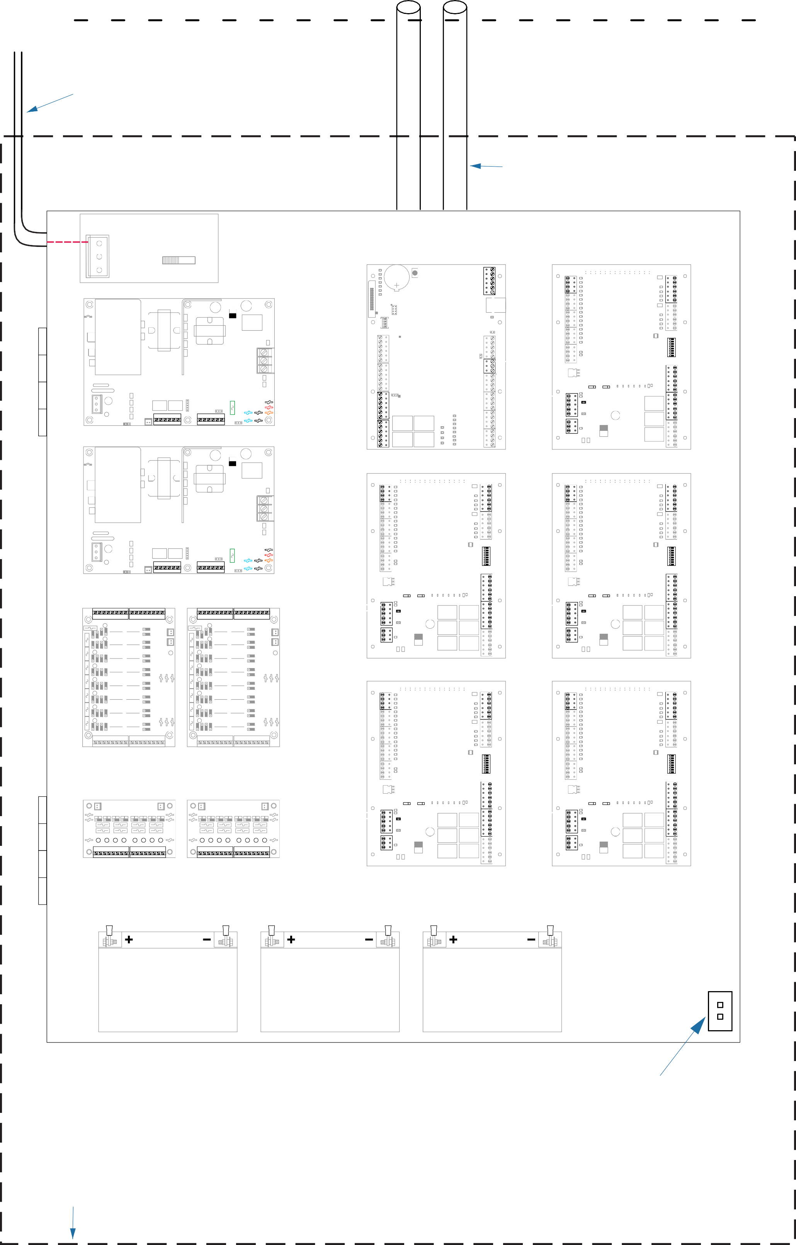

REVISED: 01/03/2025 DN
Page 3
Enlarged View Mercury Controls with LSP Power Supply

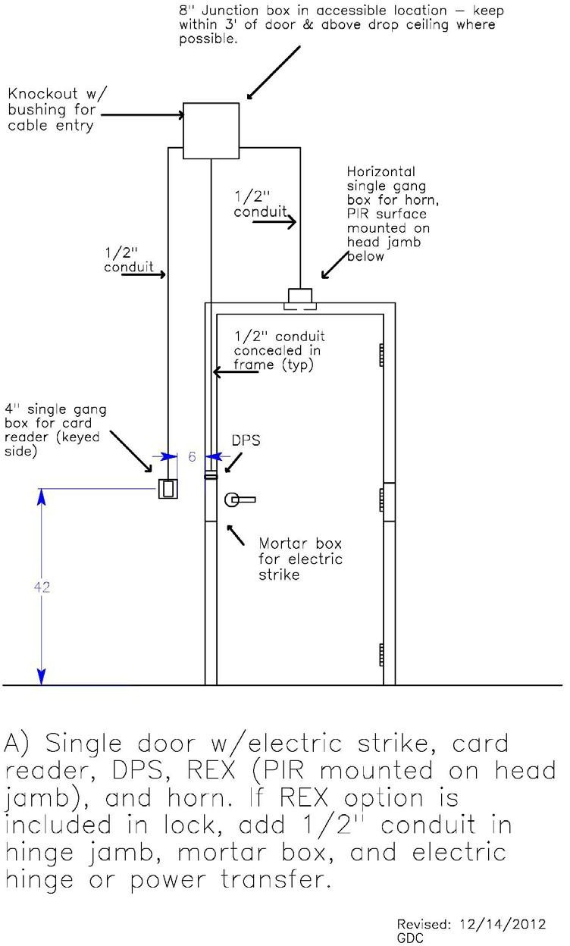
Figure F2: Squadron Controls in Enclosure

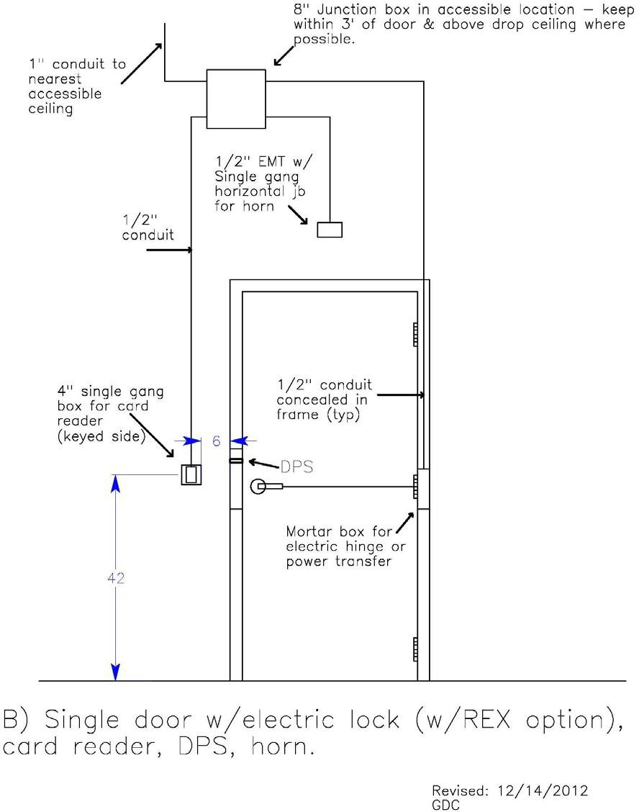
Figure F3: Single Door with Electric Strike

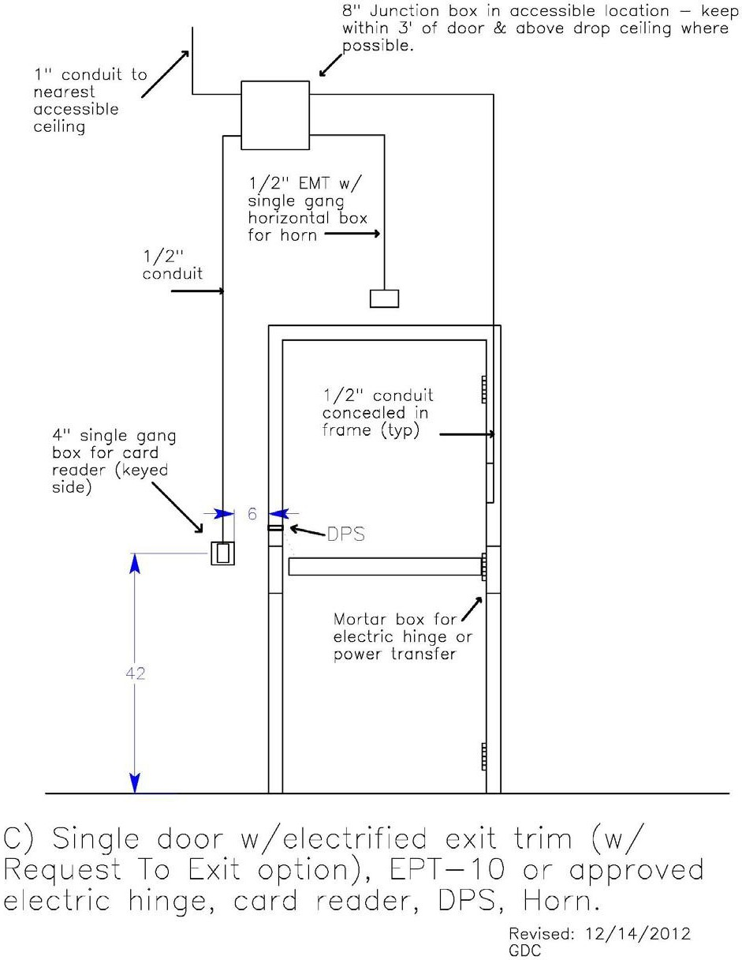
Figure F4: Single Door with Electric Lock

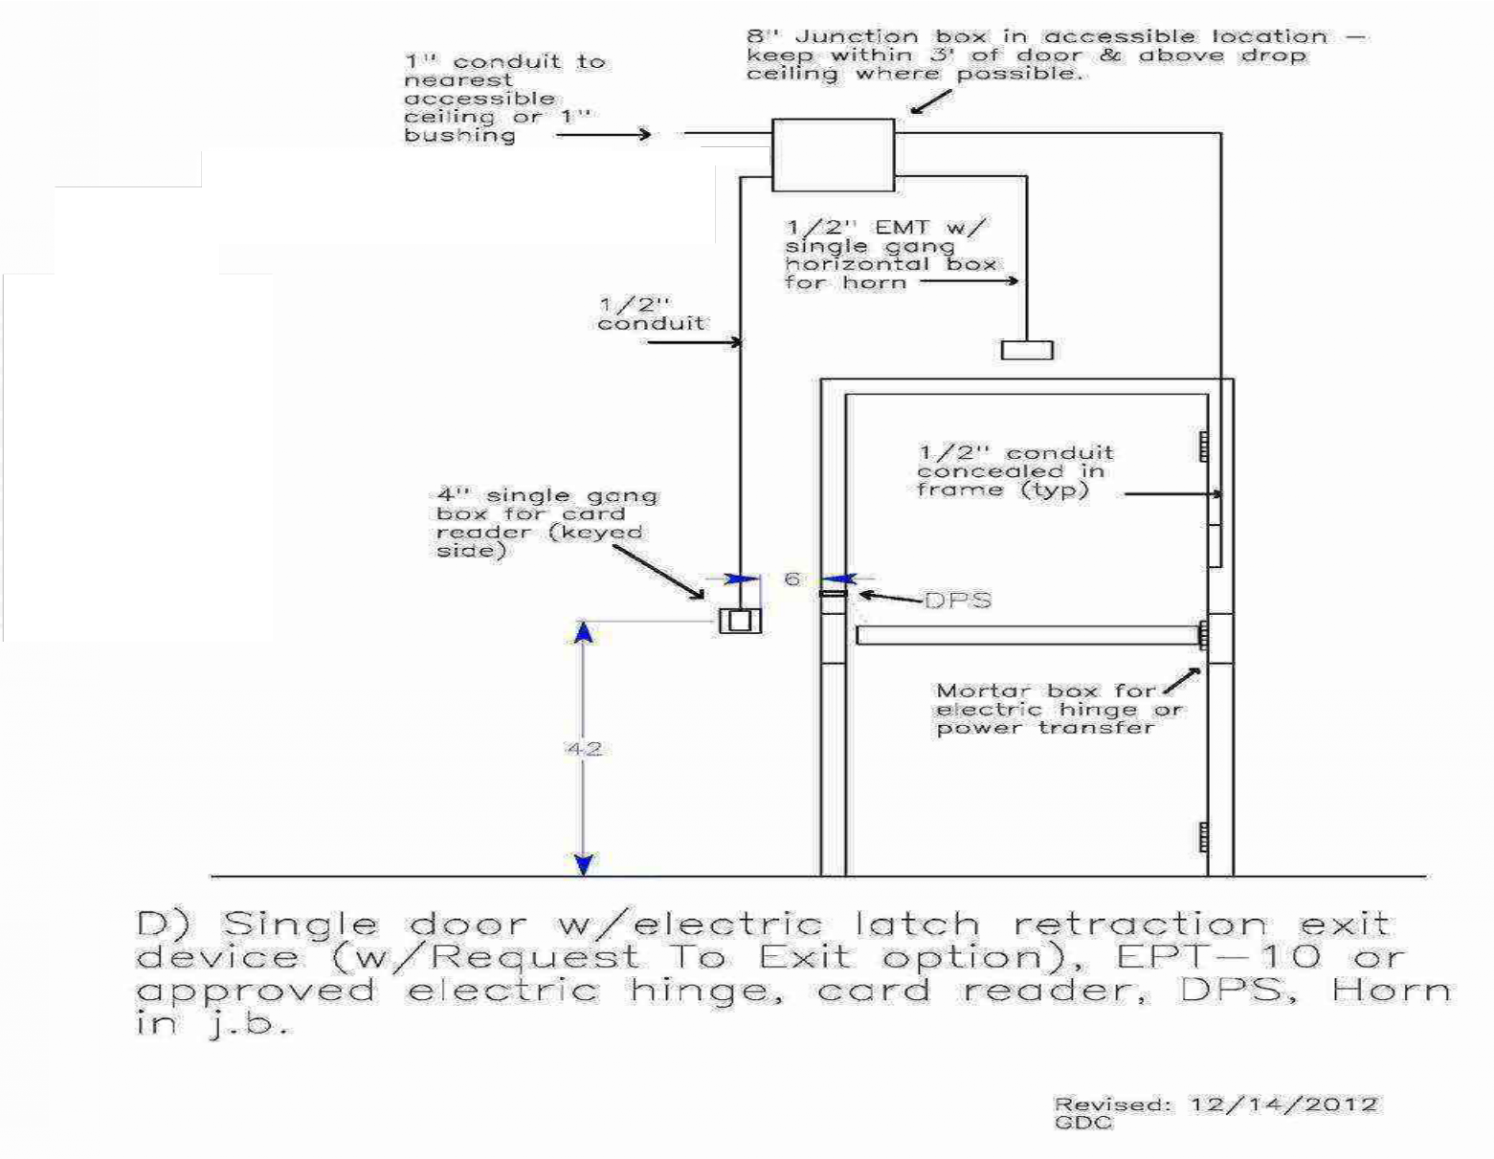
Figure F5: Single Door with Electric Trim

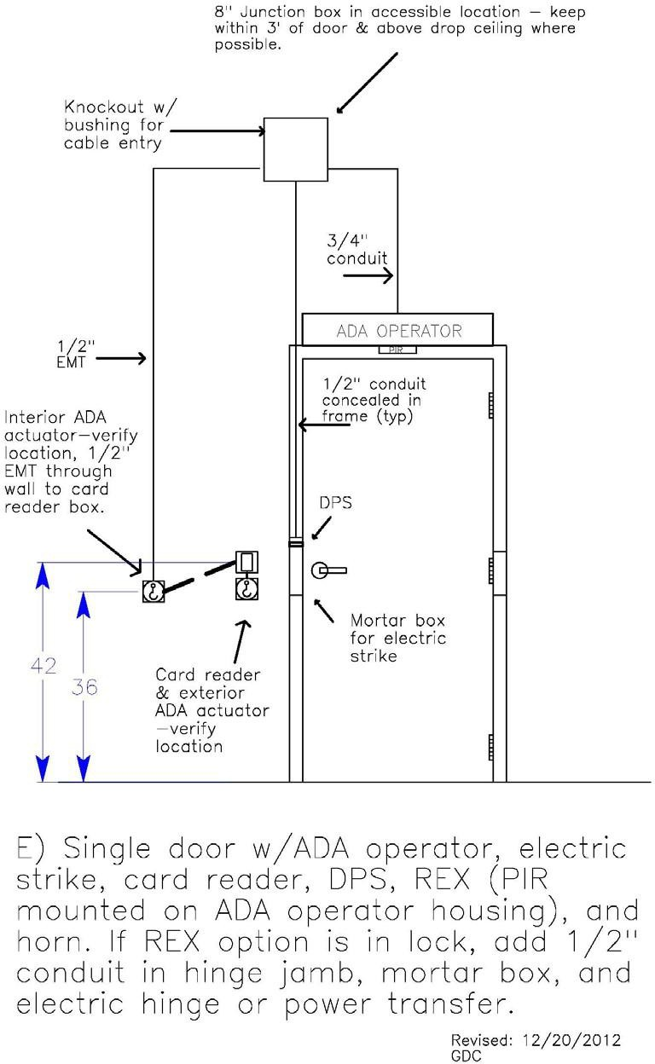
Figure F6: Single Door with Latch Retraction

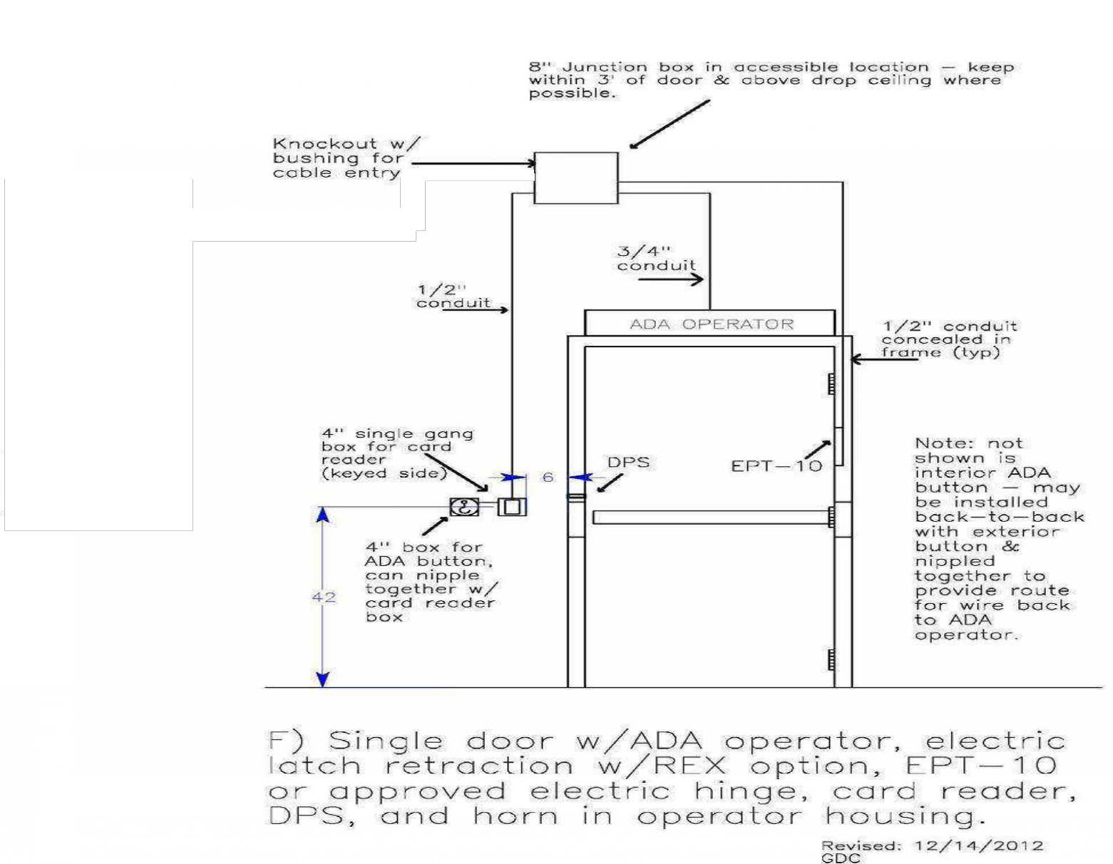
Figure F7: Single Door with ADA & Electric Strike

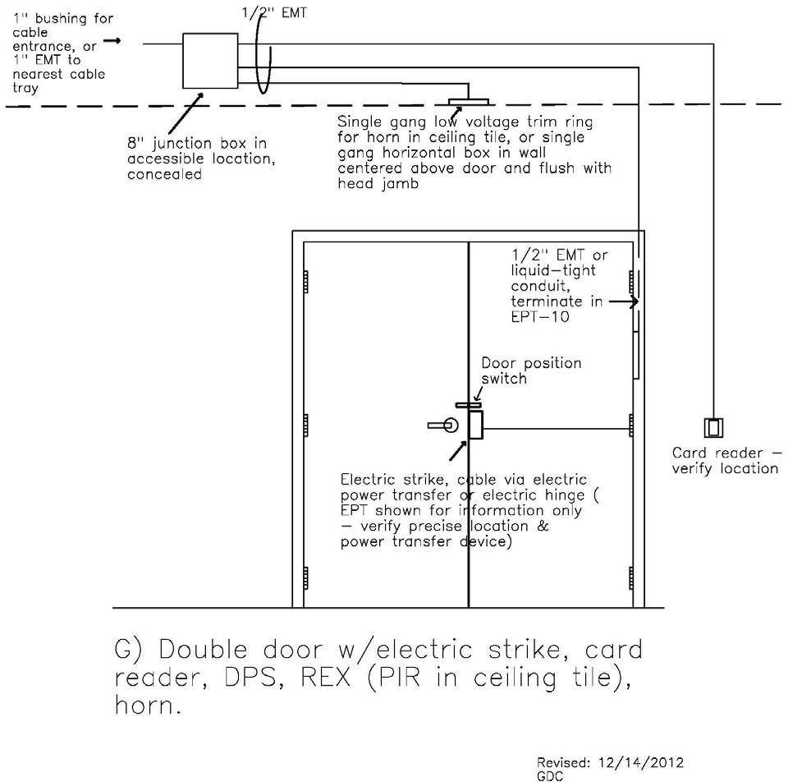
Figure F8: Single Door with ADA & Latch Retraction

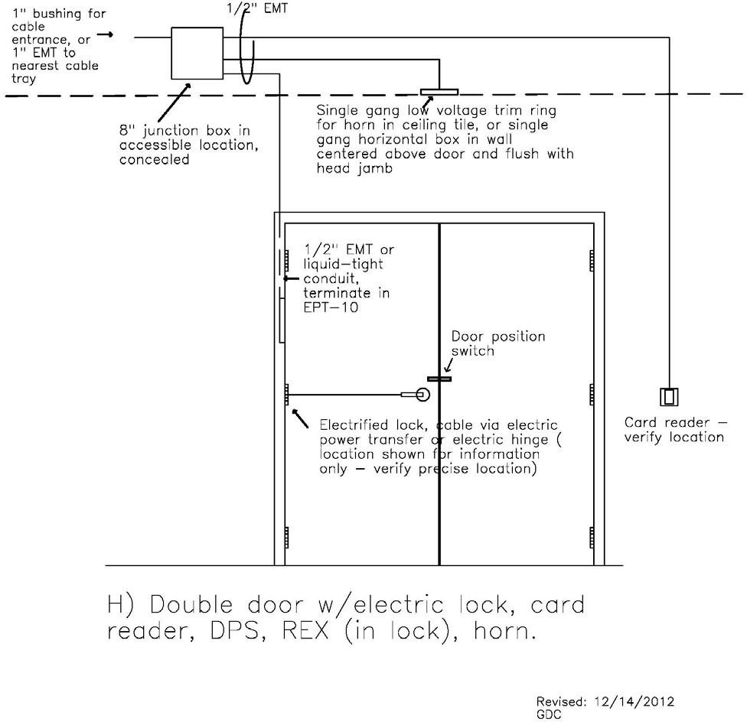
Figure F9: Double Door with Electric Strike

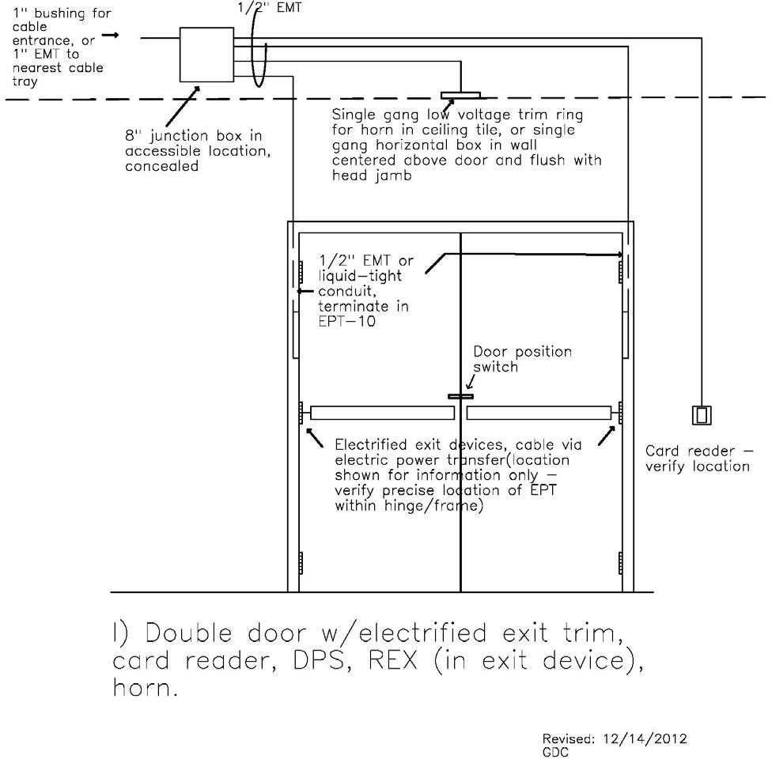
Figure F10: Double Door with Electric Lock

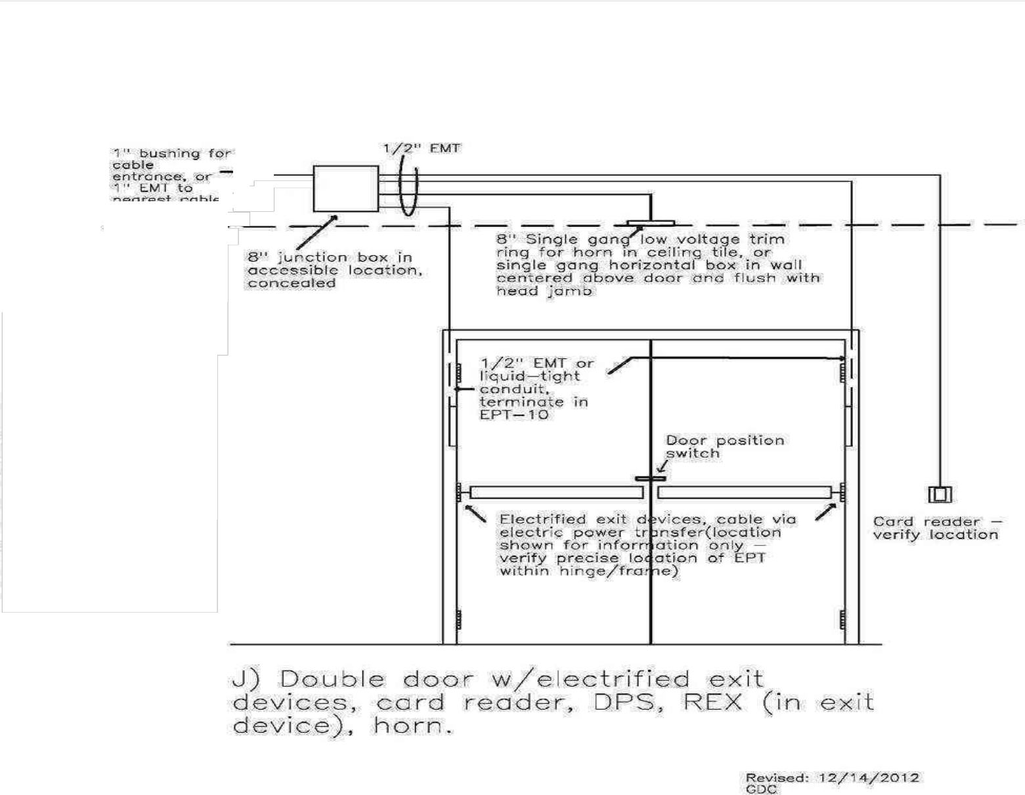
Figure F11: Double Door with Electric Trim

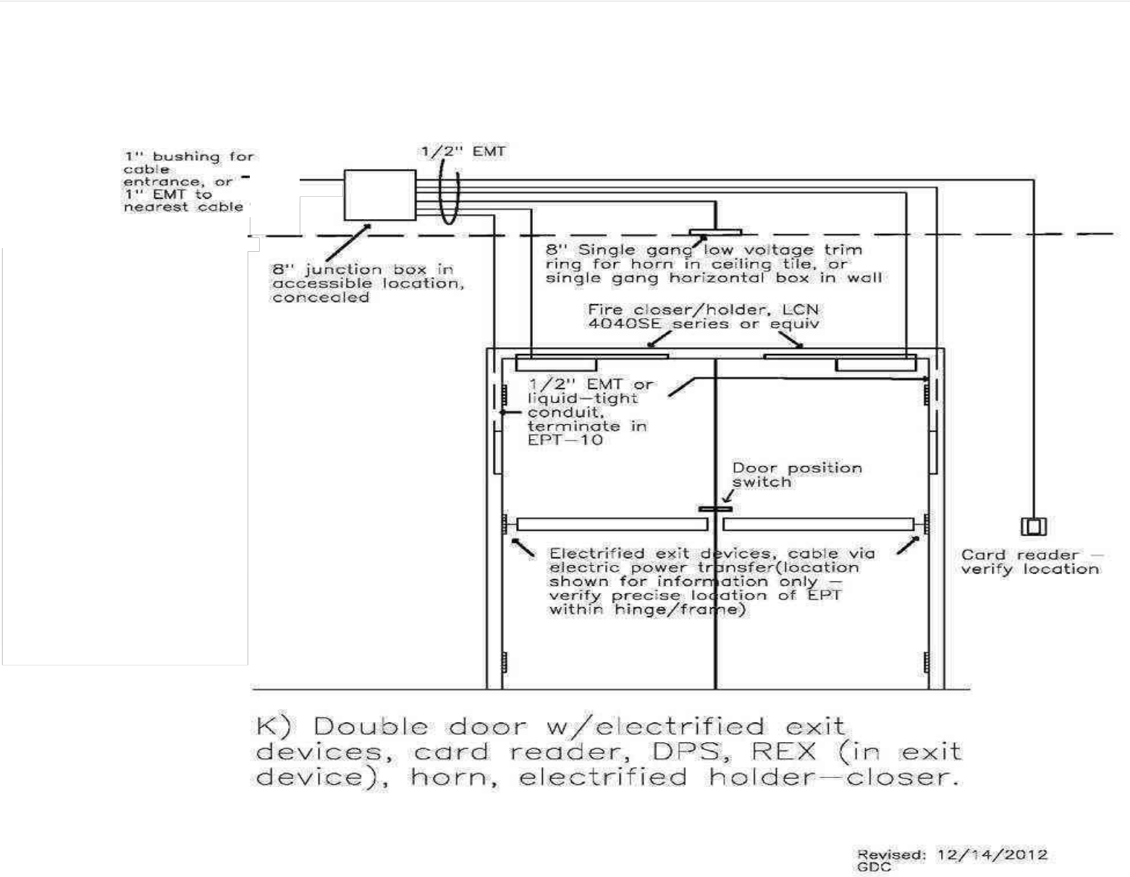
Figure F12: Double Door with Latch Retraction

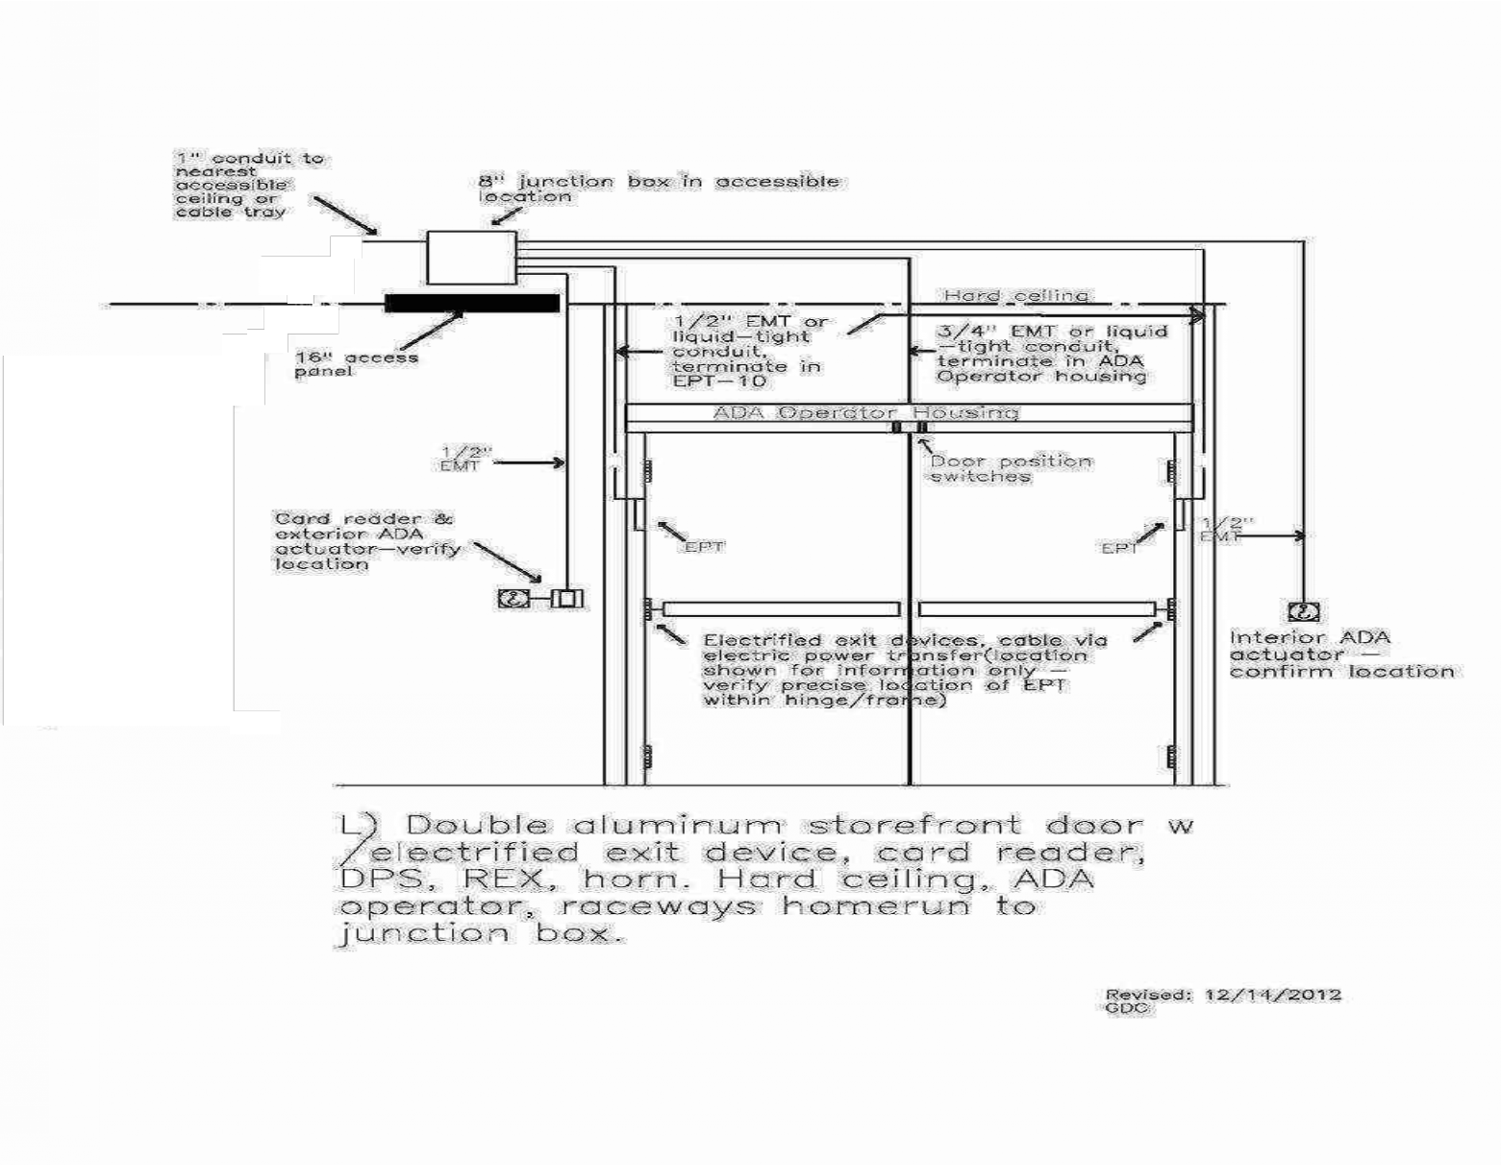
Figure F13: Double Door with Latch Retraction Holder

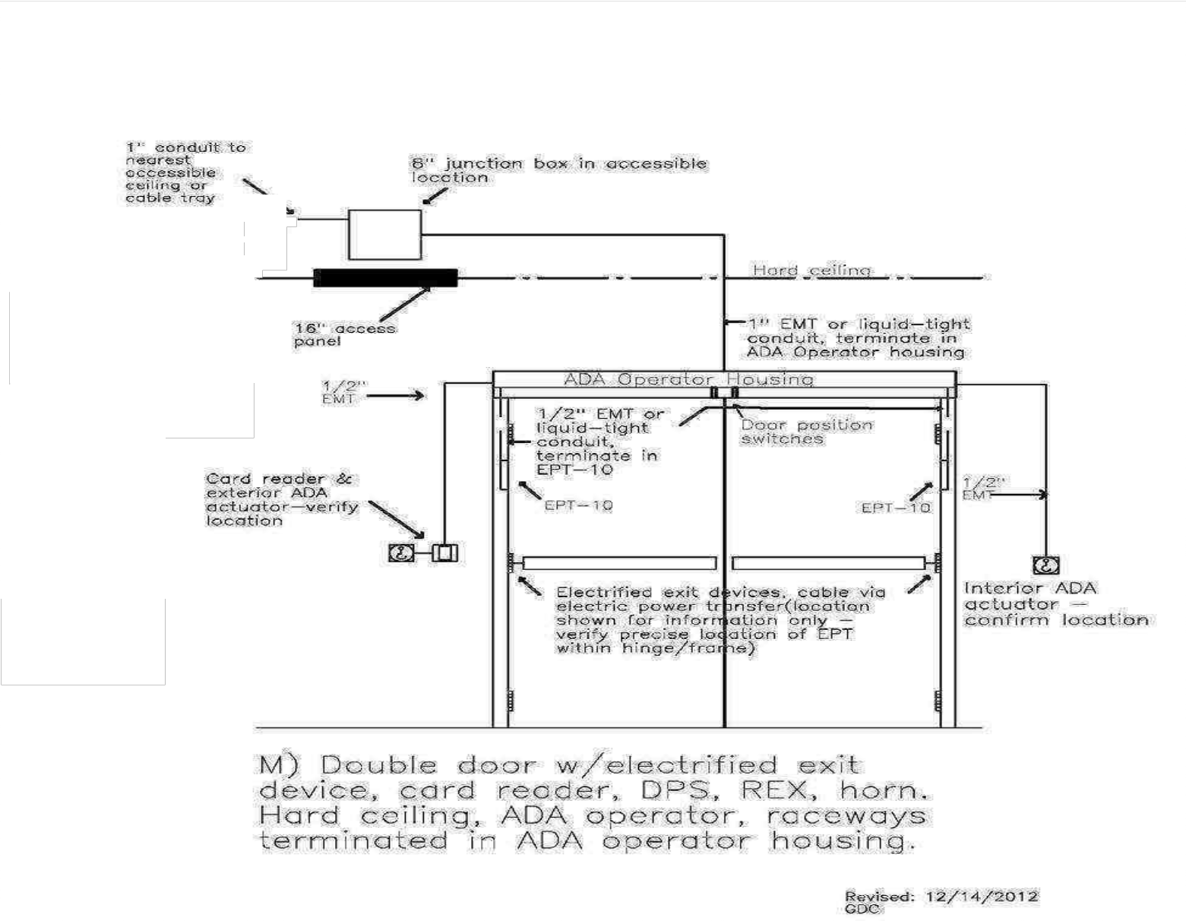
Figure F14: Double Door with ADA Latch Retraction Storefront

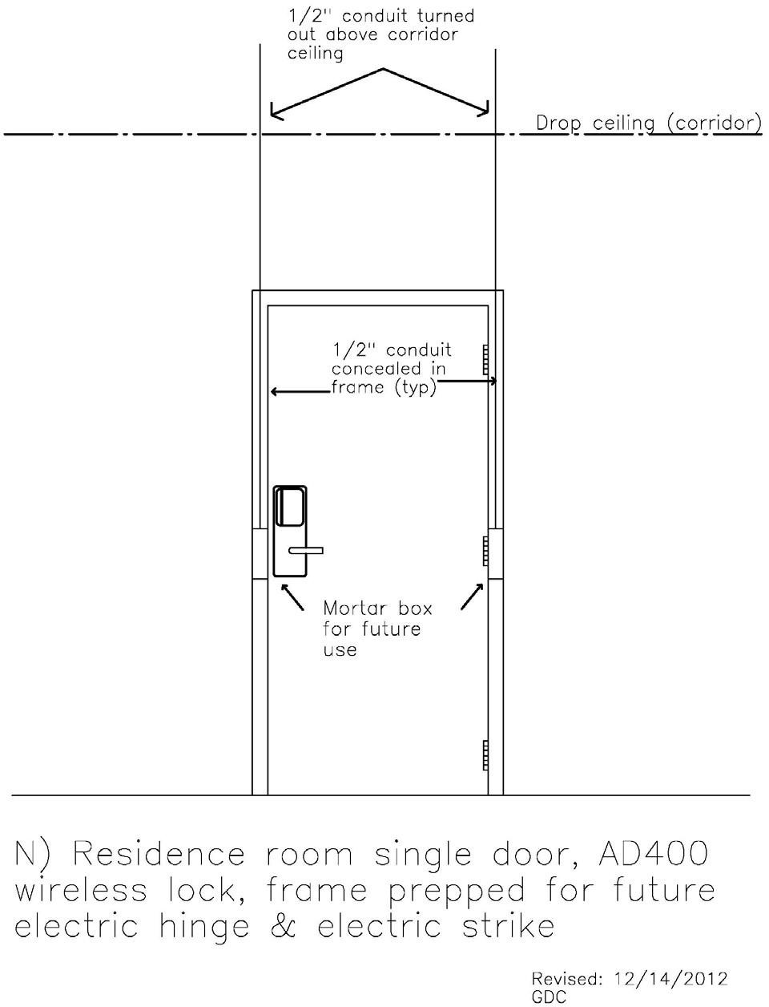
Figure F15: Double Door with Ada Latch Retraction Raceway via Operator

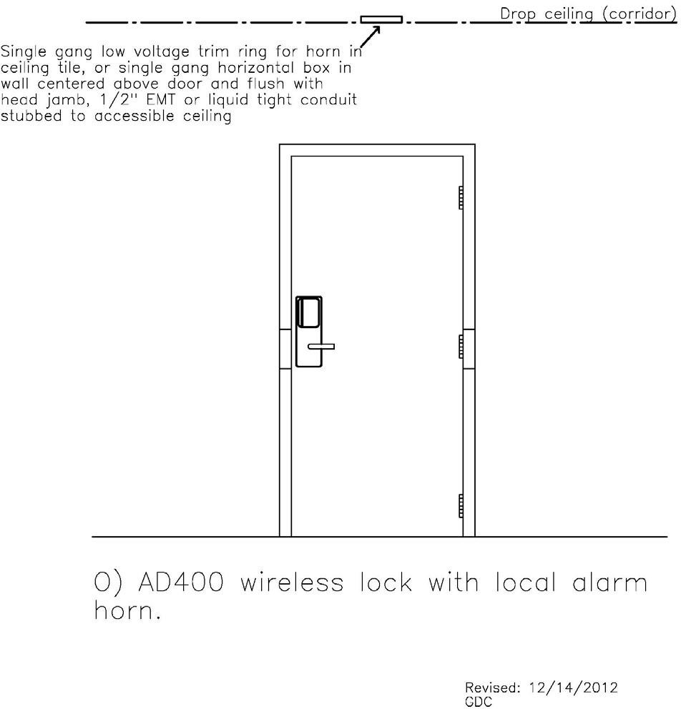
Figure F16: Residence Room AD400 Lock

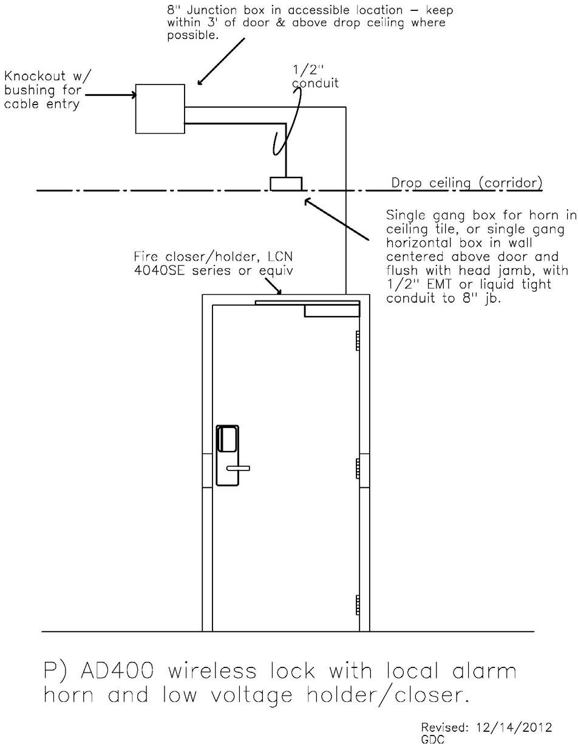
Figure F17: Wireless Lock with Local Alarm

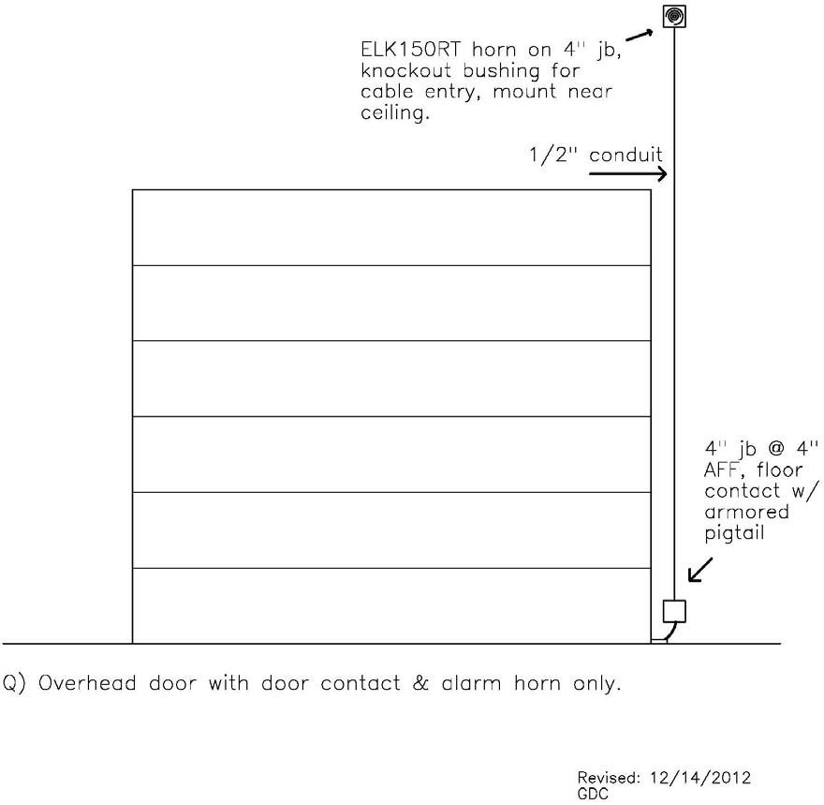
Figure F18: Wireless Lock with Horn, Holder, and Closer

Figure F19: Overhead Door with Alarm

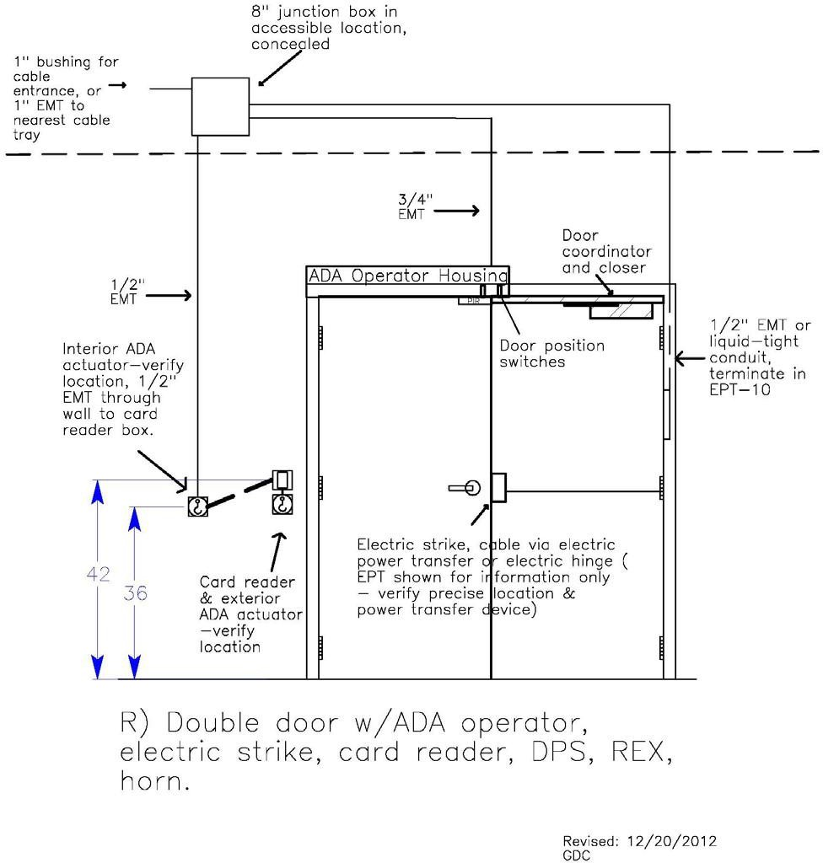

Figure F20: Double Door with ADA, Strike, Reader, Rex, and Horn

